**MINISTRY OF SCIENCE AND HIGHER EDUCATION OF THE REPUBLIC OF KAZAKHSTAN**

**“Kazakh-British Technical University” JSC**

**School of Information Technologies and Engineering**

**ADMITTED TO DEFENCE**

Dean of SITE,

A.Zh. Imanbayev

“ ” 2024

**Theme: «DEVELOPMENT OF AN ADVANCED BIOMETRIC AUTHENTICATION SYSTEM USING A HYBRID APPROACH BASED ON IRIS RECOGNITION»**

**Author: Supervisor:**

A. Yergesh Professor of KBTU, PhD

“ ” 2024 A. Akzhalova

“ ” 2024

**Major: Norms Compliance Monitor:**

7M06106 Software Engineering Senior lector

Zh. Zhiyenbekov

“ ” 2024

**Almaty, 2024**

**ABSTRACT**

The authentic detection of members is of massive importance for the betterment of security in different fields like the information security and public safety. This dissertation provides an introduction to the brand network's iris eye recognition system, which not only improves the identification of people but also helps them access the places they want to enter. The usage of the convolutional neural networks is the progression of our method which iris image segmentation and feature representation. This section consists of dataset information used before training with segmentation mask coverage, and we present a new method for obtaining iris feature representations through pretrained networks. The comparative analysis done of different methods of feature representation, classical and neural network, and of various classifiers such support vector machine, random forest, and k-nearest neighbor, shows that the proposed approach is better than all of them. This system shows a distinct performance increment, as quantified experimentally by the measurement results, which is reflected in the accuracy improvement. The implementation of pre-trained network in this research not only increases efficiency of shortening feature extracting time but also raises the adaption ability in unstable illumination and relative motion, which are typical problems of iris recognition. Moreover, scalability of our model also offers its advantages to deploy in a large-scale security system without impairing its performance at all. The present dissertation serves as an entrance point for future studies which involve hybridized neural network systems for security settings through combination with biometric modalities.

**The scope and structure of the dissertation:** 60 pages, 5 sections

**Number of illustrations, tables, literary sources:** 24 figures, 2 tables, 86 sources

**List of keywords:** biometric identification, iris recognition, hybrid biometric systems, convolutional neural networks, edge detection, histogram equalization, wavelet transform, data protection, multimodal biometric integration, classification accuracy

**Information about publications:** A. Yergesh (2024). Development of an advanced biometric authentication system using iris recognition based on a convolutional neural network. In Vestnik nauki 581-596

A. Yergesh (2023). Development of an advanced biometric authentication system using iris recognition based on a convolutional neural network. In 1st Annual Graduate Student Research Workshop on Computer Science, Information Systems and Engineering. Cham: Section II. Information Systems and Information Systems Management. Room: Independence Hall, Kazakh-British Technical University, Almaty, Kazakhstan.

**АҢДАТПА**

Жеке тұлғаны дәл анықтау ақпараттық қауіпсіздік және қоғамдық қауіпсіздік сияқты әртүрлі салалардағы қауіпсіздікті жақсарту үшін өте маңызды. Бұл диссертация жеке сәйкестендіруді айтарлықтай жақсартатын нейрондық желілерге негізделген иристі танудың жаңа жүйесін ұсынады. Конволюциялық нейрондық желілерді қолдана отырып, біздің әдіс ирис кескінін сегментациялауды және сипаттамаларды ұсынуды жақсартады. Біз оқыту үшін пайдаланылатын мәліметтер жиынтығын, соның ішінде қол жетімді сегменттеу маскаларын егжей-тегжейлі сипаттаймыз және алдын-ала дайындалған желілер арқылы ирис сипаттамаларының көріністерін құрудың жаңа әдісін енгіземіз. Классикалық және нейрондық желі әдістерін қоса алғанда, сипаттамаларды ұсынудың әртүрлі әдістерін салыстырмалы талдауымыз, тірек векторлық машиналар, кездейсоқ ормандар және жақын көршілер әдісі сияқты әртүрлі классификаторлармен бірге біздің көзқарасымыздың артықшылығын көрсетеді. Ұсынылған жүйе эксперименттік нәтижелермен сандық түрде расталған жіктеу дәлдігінің айтарлықтай жақсарғанын көрсетеді. Бұл зерттеуде алдын ала дайындалған желілерді инновациялық пайдалану белгілерді алу тиімділігін жақсартып қана қоймайды, сонымен қатар әртүрлі жарық жағдайлары мен физикалық жағдайларда көбірек бейімделуді қамтамасыз етеді, бұл иристі тануда жиі кездесетін мәселе. Сонымен қатар, біздің модельдің ауқымдылығы өнімділікті төмендетпестен кең ауқымды қауіпсіздік жүйелеріне енгізуге мүмкіндік береді. Бұл диссертация қауіпсіздіктің одан да сенімді және жан-жақты шешімдеріне қол жеткізу үшін осындай нейрондық желі әдістерін басқа биометриялық әдістермен біріктіру бойынша болашақ зерттеулерге жол ашады.

**Диссертация көлемі мен құрылымы:** 60 бет, 5 секция

**Суреттер, кестелер, пайдаланылған әдеби дереккөздер саны:** 24 иллюстрация, 2 кесте, 86 дереккөз

**Кілт сөздер:** биометриялық сәйкестендіру, иристі тану, гибридті биометриялық жүйелер, конволюционды нейрондық желілер, жиектерді анықтау, гистограмманы теңестіру, толқындық түрлендіру, деректерді қорғау, мультимодальды биометриялық интеграция, жіктеу дәлдігі

**Жарияланымдар туралы мәліметтер:** A. Yergesh (2024). Development of an advanced biometric authentication system using iris recognition based on a convolutional neural network. In Vestnik nauki 581-596

A. Yergesh (2023). Development of an advanced biometric authentication system using iris recognition based on a convolutional neural network. In 1st Annual Graduate Student Research Workshop on Computer Science, Information Systems and Engineering. Cham: Section II. Information Systems and Information Systems Management. Room: Independence Hall, Kazakh-British Technical University, Almaty, Kazakhstan.

**АННОТАЦИЯ**

Точная идентификация личности имеет решающее значение для улучшения безопасности в различных областях, таких как информационная безопасность и общественная безопасность. Эта диссертация представляет новую систему распознавания радужки глаза на базе нейронных сетей, которая значительно улучшает личную идентификацию. Используя сверточные нейронные сети, наш метод совершенствует сегментацию изображения радужки и представление характеристик. Мы подробно описываем используемый набор данных для обучения, включая доступные маски сегментации, и вводим новую технику для генерации представлений характеристик радужки с помощью предварительно обученных сетей. Наш сравнительный анализ различных методов представления характеристик, включая классические и нейросетевые техники, наряду с различными классификаторами, такими как машины опорных векторов, случайные леса и метод ближайших соседей, подчеркивает превосходство нашего подхода. Предложенная система демонстрирует значительное улучшение точности классификации, которое количественно подтверждается экспериментальными результатами. Инновационное использование предварительно обученных сетей в этом исследовании не только улучшает эффективность извлечения признаков, но также обеспечивает большую адаптивность в различных условиях освещения и физических условиях, что является обычной проблемой при распознавании радужки. Кроме того, масштабируемость нашей модели предоставляет возможности для внедрения в крупномасштабные системы безопасности без снижения производительности. Эта диссертация открывает путь для будущих исследований по интеграции таких техник нейронных сетей с другими биометрическими методами для достижения еще более надежных и комплексных решений в области безопасности.

**Объем и структура диссертации:** 60 страниц, 5 секций

**Количество иллюстраций, таблиц, использованных литературных источников:** 24 иллюстраций, 2 таблиц, 86 источников

**Ключевые слова:** биометрическая идентификация, распознавание радужной оболочки глаза, гибридные биометрические системы, сверточные нейронные сети, обнаружение границ, выравнивание гистограмм, вейвлет-преобразование, защита данных, мультимодальная биометрическая интеграция, точность классификации

**Сведения о публикациях:** A. Yergesh (2024). Development of an advanced biometric authentication system using iris recognition based on a convolutional neural network. In Vestnik nauki 581-596

A. Yergesh (2023). Development of an advanced biometric authentication system using iris recognition based on a convolutional neural network. In 1st Annual Graduate Student Research Workshop on Computer Science, Information Systems and Engineering. Cham: Section II. Information Systems and Information Systems Management. Room: Independence Hall, Kazakh-British Technical University, Almaty, Kazakhstan.

**CONTENTS**

**LIST OF TERMS AND ABBREVIATIONS** 6

**INTRODUCTION** 7

1 **BIOMETRIC** **IDENTIFICATION** **OF** **PERSONALITY** 9

1.1 Comparison of biometric technologies 9

1.2 Features of the iris 14

1.3 Structure and function of the iris 15

1.3.1 Comprehensive anatomy of the Iris 15

1.3.2 Advanced biomicroscopic understanding of the iris 17

1.3.3 Technological advances and applications of iris recognition systems 19

2 **MAIN** **PROBLEMS OF IRIS RECOGNITION SYSTEMS** 22

2.1 Technical difficulties and limitations 22

3 **ANALYSIS** **OF IRIS IMAGE PREPROCESSING METHODS** 27

3.1 Canny Edge Detection 27

3.2 Prewitt, Roberts, and Sobel Schemes 30

4 **IMPLEMENTATION** **OF IRIS RECOGNITION SYSTEM** 33

4.3 Histogram Equalization 38

4.4 Application of 2D Discrete Wavelet Transform (2D DWT) 40

4.5 Edge detection 42

4.6 Feature Vector Storage and Organization 43

5 **RESULTS** **AND** **ANALYSIS** 45

5.1 Presentation and analysis of the results obtained from testing the iris recognition system 45

5.2 Visual aids and explanations on how each processing step affects the results 52

**CONCLUSION** 54

**REFERENCES** 56

# **LIST OF TERMS AND ABBREVIATIONS**

AI – Artificial Intelligence

ML – Machine Learning

KNN – K-Nearest Neighbors

RF – Random Forest

CNN – Convolutional Neural Network

DWT – 2-dimensional Discrete Wavelet Transform

GDPR – General Data Protection Regulation

RSA – Rivest–Shamir–Adleman

AES – Advanced Encryption Standard

FRR – False Rejection Rate

FAR – False Acceptance Rate

AHE – Adaptive Histogram Equalization

Convolutional Neural Network (CNN) - A deep learning algorithm that learns to assign importance to different aspects or objects in a given input image, represented by its learnable weights and biases, in order to differentiate one from another.

Data Preprocessing - Techniques through which raw data is prepared for further treatment and analysis in data mining.

# **INTRODUCTION**

Since time immemorial, society has been established right from the simplest to the most complex where the ability to verify an individual identity greatly determines the success of any society. The traditional codes, passwords and physical mediums used to authenticate the identity of the individual while are very much used, are prone to security breaches due to their inherent limitations – they can be shared, stolen or hacked [1]. Beside the computer technology, biometric authentication has been become active in the identification process through using unique physical characteristics as one's biometric information. The stability and uniqueness of the iris's features within every human have often brought iris identification among the bunch as the most reliable and accurate biometric technique available.

Biometric systems experience essential changes over the several years from its emergence in early 60s [2], and the fingerprint recognition technology has commercially been available till now. Initially, only fingerprints formed the bedrock for biometric recognition in law enforcement, and they have since been disrupted by innovative technologies e.g. facial, voice, iris recognition that have in turn extended biometrics into other domains like government services and services and commercial applications. Iris identification is a unique technology that truly stands out for its non-invasive and accurate performance. Therefore, it is undeniably the bedrock of modern biometric systems. It can be used in electronic transaction security, border control, and in many other spheres, just to showcase its "universal" capabilities.

Iris biometrics are mainly rooted in the distinctive and unchangeable textural nature of an iris, but the latter is well suited for long-term identity authentication due to its exceptional stability. In spite of all its strengths, iris recognition technology comes with certain limitations related to data retrieval environment variations and large-scale deployment scalability. To defeat that difficulty, a consensus on hybrid model that enhances robustness and solves application deficiencies in the nature-based systems is being looked forward.

In order to increase reliability and accuracy of iris recognition systems, this dissertation proposes integration of multimodal biometric systems which combine iris biometric data with other biometric traits. The resulting system is stronger against the various attacks and against the environment variations. Additionally, these complex procedures, such as machine learning and deep neural networks are used for the improvement of the precision of feature extraction and recognition processes. These computational enhancements are central to reaching the required processing speed in real time though high levels of accuracy.

Despite the fact that iris recognition has its advantage, this pattern of recognition isn’t immune to the challenges faced. One major challenge related to the environment where data acquisition happens is unstable illumination and camera quality. These complications can make the whole system not as accurate as it can be initially. Also, in addition, the more substantial magnitudes of the deployments require advanced algorithms which can be effective in processing very large datasets without losing speed and precision. In this regard, the necessity of moving beyond the technology limitations is acute to find not only the ways on how to augment the reliability of iris recognition systems but also to solve the observed issues in the real world.

My aim for this project is to design, construct, and conduct the proof-of-concept prototype for a hybrid biometric identification mode that is powered by iris scanning. The evaluation will focus on how fast the system can identify a suspect, detecting errors, effectiveness in terms of cost and credibility of output being reliable. To achieve this, the dissertation will explore: To achieve this, the dissertation will explore:

* Analyzing the practicality of the algorithms in question for iris image preprocessing.
* The development of course-related algorithms for data preprocessing.
* Innovated implementation of the rapid and accurate eye iris segmentation.
* Approximately equal time spent on experimentation that involve both time-tested and promising identification procedures.

The scientific contributions of this dissertation include:

* A detailed discussion concerning a sophisticated research of iris pre-processing methods in the current day.
* Creation of a multiscale image element rapid-scan method for iris racialization.
* Application of component position information from complex wavelet transformations for identification aims by adding the discriminating power of the system.
* An Iris Method built on Gabor filters' responses, optimized the computing efficiency and speed.
* Formulation of novel identity identification algorithm that is also robust against tilts to the head (rotation variations).

The practical implications of this dissertation which showed how effective approaches and algorithms in vogue now could be improved by introducing our advancements in the field of iris recognition and thus provide a robust scalable solution for real world use cases. Having a good working prototype is a prove of our methods success. It is relaying the method upon which we shall build various other technologies based on biometric authentication.

For defense, this dissertation will present:

* Hardware of the cameras is not the only important part - also the novel iris localization algorithm with high speed and accuracy.
* A design of an iris-based recognition system that combines both discriminative power and computational efficiency while maintaining greater security at the same time.
* Implement identity algorithm of innovative nature addressing the problem of projection of image which takes place in conjunction with the twisting of a head.
* Detailed comparison results of the both convenience measure and innovative techniques.

# **BIOMETRIC IDENTIFICATION OF PERSONALITY**

The integration of biometrics technologies into persona identification systems is the beginning of a brand-new age in biometrics research. This novel imperative is not only about digital profile markers, but it goes further into the complex area of psychological features such as physiological and behavioral biometrics. The hypothesis put forward by this research postulate that your face, the mixture tone you use when you talk and even how you walk could be sufficient indicators of your hidden personality. These insights can not only transform the security sector, the human resources management, and the marketing strategies but also offer a new perspective and area of improved and predictable analytics.

It is only possible to fully realize the potential of these systems using the advanced algorithms that can dissect and interpret the intricate subtleties of biometric data. Machine learning is critical diving deeper into the process of subtle biometric indicators that can help detect and learn about one's personality. Such algorithms have been developed to help the computer process large amounts of data and extract meaningful patterns that correlate to the biometric behaviors with the related personality traits.

On the other hand, the biometric data's ability to draw inferences on personality traits also comes with its own challenges. Moreover, it is quite relevant to talk about ethical and privacy questions such as possibility of the biometric data misuse. In addition to this, one might imagine the scenarios where a predictable or inferred information is used for harmful ends of privacy violation or discrimination. Hence, the authenticity of these services is among the major issues that the topic of future facial recognition systems addresses.

## **Comparison of biometric technologies**

The biometrics field is an interdisciplinary one, specifically touching upon both the technological and the science realms. Identification and recognition of persons are the chief emphasis, relying on their distinct physiognomies or personal mannerisms. Facial Biometrics includes all the associated biometric modalities except for face. The popular ones include Finger Print Identification, Thermal imaging of the face,Iris-scan, gait analysis,etc. The most popular examples for genetic fingerprinting are DNA analysis for its extreme accuracy and gait analysis for its noninvasive institutions that acknowledge the consent of the individuals for them to use their information in any way. For a biometric characteristic to be successfully implemented in real-world applications, it must satisfy several crucial criteria [3, 4, 5]:

1. Universality: Any bodily traits deemed suitable for widespread use must be absolutely universal and present in all the members of the human race as a common property, which would address the issue of admissibility to the maximum level in relation to a huge set of people.
2. Uniqueness: It is a mandatory for the trait of biometric which will act as an identication tool to show up a clear differentiability in individuals. Despite individuals having a set of features in common, the trait should be possessing a notable degree of distinctive qualities in order for the distinct identity of this person should be highlighted.
3. Permanence: Traits can be considered reliable only from the standpoint of their stability. They should not be affected by the individual lifelong aging process or the possible environmental changes going on around the individual.
4. Measurability: It must be unambiguous and simple for detection by the biometric system in order to provide a basis for identifying/classifying a person. Consistency is paramount for ensuring the validity of trait as the only measure that could be collected in a reliable and accurate way using different technologies and devices.
5. Performance: This metric indicates if the biometric system has an acceptable level of performance testing for the trait used, and it is considered based on the trait’s accuracy, speed, and reliability. In addition, the system will review the data and operation efficiency of the system under various real-world conditions and will be muster in the error handling during the identification process.
6. Acceptability: A certain level of social acceptance shows how well people are keen in the use of a specific trait for biometric systems in general.
7. Circumvention: Herein, the assessment of the feature is considered, mostly its resilience to counter the activities like spoofing that lead to duping or copying.

The diversity in the application of biometrics is a defining feature and allows these systems to be deployed for the purpose of national security, personal identification verification, access control and to prevent fraud in banking and personal devices. A variety of characteristics may be present in different traits, and each trait might be not suitable in certain cases.

Table 1.1 – Comparison of Common Biometric Technologies Based on Key Performance Criteria

|  |  |  |  |  |  |  |  |
| --- | --- | --- | --- | --- | --- | --- | --- |
| Biometric Technology | Universality | Uniqueness | Permanence | Measurability | Effectiveness | Accessibility | Protection against Forgery |
| Fingerprints | High | Very High | High | High | High | High | High |
| Face | High | Medium | Low | High | Medium | Very High | Medium |
| Iris | High | Very High | High | High | High | Medium | High |
| Retina | Medium | Very High | High | Medium | High | Low | Very High |
| Dynamics of the signature | Medium | Medium | Low | Medium | Medium | High | Medium |

Continuation of table 1.1

|  |  |  |  |  |  |  |  |
| --- | --- | --- | --- | --- | --- | --- | --- |
| Voice recognition | High | Medium | Low | Medium | Medium | High | Low |

The comprehensive comparison of common biometric technologies based on key performance criteria is elucidated in our study. This analysis rigorously examines each biometric modality, including facial recognition, fingerprint analysis, iris scanning, and voice recognition, among others, against a set of critical performance metrics such as accuracy, speed, scalability, and user acceptance. The specific performance thresholds, detailed evaluation norms, and statistical analyses conducted for each biometric technology are systematically outlined. For those interested in a deeper dive into the quantitative results and detailed performance benchmarks of each model, these findings are extensively documented in Appendix A, particularly in Table A.1, which presents a structured and comprehensive compilation of all data points and metrics evaluated during our experiments.

To give a more in depth and a thorough review of the specific performance metrics for the different types of biometric technology scrutinized in the table, let us extend the discussion with more extensive discourses on the cost, convenience, and functional implications of each mode.

Biometric technologies could either end up being too costly to implement, cumbersome to operate, or even uncomfortable to use. Special systems, for instance those made for retina, iris and hand shape recognition, are often resource extensive and their costs are accordingly high. This group of systems are using to of optical equipment that high cost and not only difficult to get but also to maintaining this they are increasing the total cost of ownership (see Figure 1.1).

1. Fingerprints: Among the most expensive biometric devices in the market category are the sensors of this technology which are somehow available to be used for other purposes with quite a low price due to their frequent integration into various consumer devices such as smartphones and laptops as well. This technology is budget-friendly as the sensors are cheap; thus, the fingerprint recognition system allows for many people to have access to the technology at a low cost [2].
2. Face Recognition: The price of the technology to use facial recognition can differ a lot. Common applications that involve standard webcam are often on the budget side of technological cost, with webcam modules being found in a wide range of common devices. Nevertheless, other systems comprising high-resolution cameras and complicated pixel processing software can be more expensive to obtain [10].
3. Iris and Retina Recognition: This category include on the more expensive ranges as they require the specialized infrared cameras, but as well, the way of imaging technology is relatively complex. On the one side, the certification provided by advanced technologies falls short of those offered by human factor and the steep costs of acquisition and support makes their penalization to high-security areas only [6].
4. Voice Recognition: Among the reasons that voice recognition is hitting the market is its mostly affordable price, which is not based on special hardware apart from a standard microphone already built into most current devices. Such technologies give a lot of evidence of the short way to development and attraction due to the fact that it has become widely used in online consultation systems and customer service automation [6, 7].
5. Dynamics of the Signature: Identifying systems that recognize signature dynamics in a moderately priced offers an excellent opportunity. They will have you sign on digital tablets or electronic pens to add the swash, speed, rhythm and diverse performance of your signature [6, 7].

The advantage of biometric systems would strike another critical factor as well consequently. Such methods of user interaction can be an inconvenience when compared to the process of posing one's face in a fixed location or capturing a fingerprint or signature by using a certain device. Technologies where user does not need to provide active feedback or perform particularly actions are, user-friendly and conducive to the merging of these technologies into everyday life smoothly [4].

1. Interactive Systems: With retina and iris scanners, the users have to interact directly with the scanner frequently and very closely, which isn’t suitable and pleasant for long-term use. Just as the way in which facial recognition systems that need users to stay in the frame can negatively affect the user’s experience, the same issue turns up [8].
2. Non-interactive Systems: Biosensors and voice recognition system, where people merely touch the sensor or speak naturally, are more convenient and have been taken as more normal and fit successfully to the devices usually used [8].

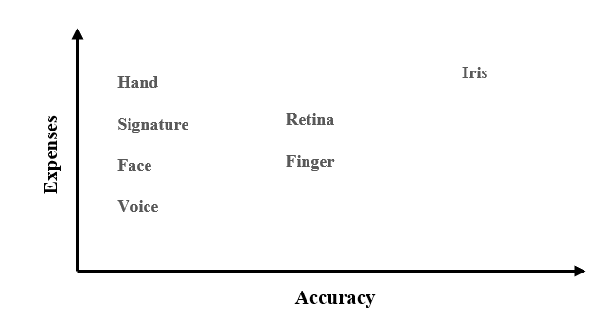

Figure 1.1 Cost vs. Accuracy Comparison of Biometric Identification Technologies

The effectiveness of biometric solutions is largely dependent on the degree of scalability and the integration capability of the technology across different platforms. Systems which provide simple integration with existing security infrastructure and require only minor adjustments are greatly valued [8]. For example, some biometric methods which can be easily integrated into existing hardware might be making it faster to deploy and more widely accepted. The function of environmental adaptability is as an important factor as well, particularly for systems that are open and uncontrolled like outdoor public places, which means that systems should be robust to the changing weather conditions and lighting variations. The system’s complexity influences the maintenance needs; the preference is for simpler plants with fewer moving parts and little or no complex requirements because of their lower maintenance needs and higher durability. At last, local vs. cloud data storage affects the efficiency of system operations, and the security as well, cloud-based systems being scalable but requiring extensive data protection measures. The highlighted discussion above evidences the need for constructing biometric identification systems that are flexible, scalable, and thus ready for modularity, which would enhance the fit into various unit types as well as effectiveness in their defined environments (see Table 1.2 as below). Even though every biometric technique is inevitably harboring its specific limitations, the ones that manage to find the golden-mean between the important aspects can become evolutional. Through focusing on the aspects of variability, build-up, and applicability all in one piece that are part of the creation and application of the system of biometrics, the possibilities are opened for the magnitude to expand and effective action to be taken. Therefore, wholistic systems, which meet different usage motives, maximize the benefit that biometric technologies can deliver [9, 10].

Table 1.2 – Impact of Biometric System Design Factors on Implementation and Maintenance

|  |  |  |  |
| --- | --- | --- | --- |
| Factor | Importance | Impact on Implementation | Impact on Maintenance |
| Scalability | High | Selects one between expansion of system capacity using redesign or not. | It cuts short the safe, operational period therefore the ability to withstand large amount of loads is lost. |
| Integration Ease | High | Affect the design and its easy of integration systems into new and existing infrastructure. | Simpler systems consist two of the components: less complex maintenance and less repairs to the system. |
| Environmental Adaptability | Medium | The most important aspect for mechanical systems installed outdoors or in varying condition is that they have the ability to have critical engineering choices and material selections enormously affected by them. | Systems exposed to harsh environments may require more robust maintenance schedules. |
| System Complexity | Medium | Complex systems may demand enhanced skill levels and use of technological competence which form part of implementation processes. | The higher the complexity involved the faster time the things may go wrong and more specialized maintenance requirements are necessary. |
| Data Storage Type | High | The option for the local or cloud storage varies the security strategy and integration complication. | It could be much easier and less expensive to sustain your local system but what if the network gets down? You cannot do remote data management either. |

## **Features of the iris**

Iris recognition is a sophisticated method of biometric authentication that employs the highly distinctive and multi-dimensional features of iris to authenticate the identity of individuals. The aim of this method is to use the complicated structures, like bands, furrows and freckles that are found only in the same eye and does not change, even among other twins with identical characteristics. The reliability of the iris structure, which is featured with high complexity and randomness, is the most satisfactory feature for secure identification purposes.

The iris recognition application process usually starts from capturing a high-resolution image of the eye using specialized cameras that generally use near-infrared illumination to better visualize the intricate patterns of iris. The first feature is aimed at the retinal illumination, which guarantees that the irregular pattern in the iris is visible and can be captured even under different illumination level conditions. Following this separation, advanced image processing algorithms identify and separate the iris from the rest of the eye image, ensuring accuracy by normalizing it to fit different pupils sizes and directions. Once the unique eye pattern is converted into digital format, this verification usually takes a fraction of seconds.

A major advantage of iris recognition technology over fingerprints is that the technology is non-invasive, which means nobody gets exposed to health issues and using it is easy. Technology requires no direct contact with a scanner, which completely alleviates the risk of viruses' spreading and increases public acceptance of it. This function is more value gaining in cases of rapid cleanliness like in hospitals and airports (see Figure 1.2) [9, 10, 11].

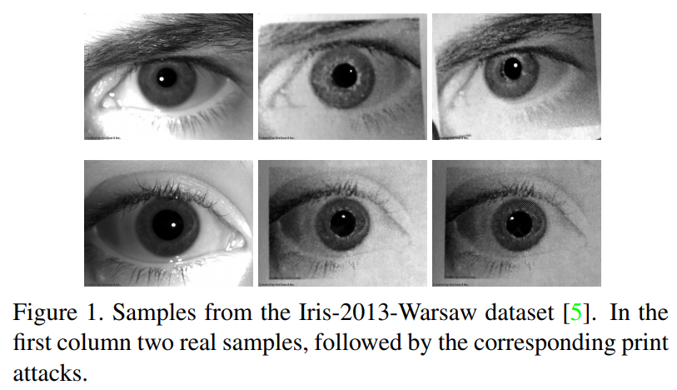

Figure 1.2 Examples of iris images

In addition to iris recognition systems that are highly secure and challenging to defeat, they are also difficult to copy or replicate. The subtleties of iris patterns in high resolution almost can not be replicated perfectly, thus biometric impossible to be imitated and making biometric very secure against fraud. With more advanced anti-spoofing technology that is able to detect unnatural eye movement and pupil dilation response being added to the already existing factor of authentication, it becomes even more reliable [73].

Although what certainly be regarded as a hefty upfront capital investment is necessary for the purchase of high-end identification technology and its software, iris recognition technology however doubles back as a cost-effective long-term solution. The high initial expenses are readily accepted with the knowledge that these tools can deliver nothing short of exceptional accuracy and security information those who will value them in their various areas of operations. These include the operating cost advantage because of the minimum maintenance required and its throughput ability. Because of this scaling feature, iris recognition emerges as a desirable option for national identity programs, immigration control, and finally, for other applications where security and efficiency are precious.

Iris technology provided by a variety of platforms shows the unique features of good adaptability and flexibility [12] that proves this technology as the most important part in the biometric identification system systems creation process today. That flexibility of technology is the foremost and a predominant trend in enhancing security and identification processes now and in the forthcoming era all through the world. As technology develops and its applications in daily life become more in-depth, it is expected that iris recognition will also be quite relevant and prominent, thus becoming a great asset in terms of security. In this section of the paper, the discussion is going to cover the particular aspects of iris recognition as well as advantages. Therefore, the question of its importance in the biometric security is going to be answered.

## **Structure and function of the iris**

This section of the dissertation covers the iris as the essential item of the eye and analyzes it in details as a scarce microscopic structure, which can help in biometric identification. Each subsection delves into different aspects that elucidate both the biological and technological relevance of the iris.

### **Comprehensive anatomy of the Iris**

The iris, the colored area around the pupil and next to the outer part of the eye, holds imperative position of overseeing the amount of light that gets into the eye. It consists of two primary layers: into the stroma anterior fibrillar matrix (connective and pigment tissue), with 2 layers of the epithelium backside, where the melanosomes are found (see Figure 1.3) [15, 16, 17].

Embedded within the stroma are two muscle types vital for pupil size regulation: the sphincter pupillae and the dilator pupillae constantly adjust the size of the aperture located within the pupil. The pupil's circumference is controlled by the sphincter pupillae, the muscle located in the edge of pupil. This muscle contracts to lower the pupil size through bright light, stimulus. To counteract with the former structure, there is a radial extensor muscle of the pupillae which contracts in darkness to expand the pupil. This an active kind of change happens only at the corona, while the iris is static outside the iris [15].

The iris near to the back of the iris consists of a layer of the iris pigment epithelium made up of cells saturated with pigment which block the passage of light to the iris, thus ensuring the passage of light is through the pupil only. Anterior uveal part is composed of the iris root, which connects the iris to the sclera and anterior ciliary body. This ensures the correct form and positioning of the iris. Beside Iris channels, the Trabecular Meshwork right near the iris root is the drainage channels of the aqueous humor from the eye that is responsible for an intraocular pressure variation and ocular health [14].

The iris becomes wider than confined to the pupillary zone that is right on the pupil's border and the ciliary zone which expands to the ciliary body on the surface of the eye. The collarette, a part that outlines this change in zones, is the most substantial of iris and this is considered to be homologous with embryonal pupil covering. It makes a boundary line between the sphincter and dilator muscles. The blood flow to the root of the iris is underlined through the corrugation of the radially running ridges, which emanate from the root to the pupillary margin, proving multiple vascular supply to the iris [13, 16].

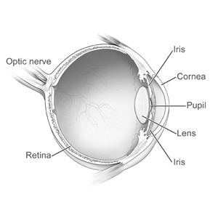

Figure 1.3 The structure of the iris

Iris, which is located in between the cornea and lens, is the part of the eye that handles the irradiation of light around the retina and divides intraocular space into the anterior and the posterior chambers. The gravitational field possesses the elliptical formation with the major diameter as around 12.5 mm but the diameter is close to 12 mm by vertical [18]. The iris is shaped very much like a truncated cone but flattened to the extent that the pupillary aperture tilts, producing an irregular conical structure that is not perfectly symmetrical. The reticular layer is the central layer which takes the center position, although some portions are not this thick but on an average 300 microns as are the other inner or outer layers [18].

The iris, as it were, is physiologically the main regulator that determines the level of light that hits at the back of the eye. It has the capability of varying the width of the pupil, resulting in it being 2 mm when it is constricted and 8 mm when it is dilated, under varying varieties of stimuli. This adjustment is carried out by two intrinsic muscles: the sphincter pupillae, which contracts to reduce the pupil size when exposed to bright light or when focusing on near objects (a process known as accommodation), and the dilator pupillae, which enlarges the pupil under low light conditions or during states of arousal. The pupil's slight displacement towards the nose and downward positions it in continuous contact with the lens, facilitating smooth movement across the lens surface [19, 20].

Moreover, in addition to illumination regulation, the sharpen do not stop here, but they also help in draining of intraocular fluid as well contributing to the regulation of intraocular pressure. The lengths of the pupil diameter is conditional on the interior pressure within the anterior chamber and these can themselves exhibit fluctuations, distorting the diagnosis and effect of conditions like glaucoma. Many factors are involved in this fluctuation in the size of pupils such as the level of the ambient light there, mood, tiredness, and inner processes, like breathing and reflexes. All these together have an impact on the pupil behavior for Cognitive physiology and the affects associated with it during the Ecological phenomenon [20]. The iris, which functions in a multi-dimensional role by receiving and interpreting the nervous signals targeting various sensory and motor organs, is a key contributory factor for studies aimed at understanding the functioning of the mind, nervous system, and common body system issues.

### **Advanced biomicroscopic understanding of the iris**

The human iris portrays an inimitable specter of color, patterns, and topographic features on its unique surface collectively being its identity as well as a significant biometric marker. At an larger scale, the iris has several major structures which are useful during the medical examination and biometric identification as reference points (see Figure 1.4).

Among the anatomical features of the iris are several zones, out of which they exhibit unique characteristics. The pupillary zone this is the central feature, surrounds already the pupil. This area is very densely populated by varieties of fibers which are referred to as trabeculae, and these fibers are very essential for the functions of the iris, especially on mechanical activities. These fibers, unlike the usual blood vessels in gray irides, are about 1-2 mm wide and generally more evident on blue or green irides when the circular muscle surrounding the pupils, known by the pupillary sphincter, may be visibly protruded appearing from there as a slightly yellowish circle [21, 23].

Pupillary zone is adjacent to it. It is known as a pigment fringe and is defined by a clear surface with the large amount of pigment within the cells. The pigment or fringe of this individual covers a vast delta of variance compared to the majority of the population with most of the people reportedly have a range from 0.04 to 0. It is 11 mm in length, or roughly the size of the width of your thumb, and every structure in the eye is dependent on it in one way or another [21].

Moving peripherally from the iris root is the ciliary zone that spans 3-4 mm from its root to the partly ensured ring. This region is characterized with a highly developed and variable relief, constituted by circles of the iris and numerous radial strands that perform anastomosis with the major blood vessels of the iris. This area will have formations that may convolute or be oblique. Surface deformations will be distinct and will include features such as contraction furrows and adaptation arcs that are concentric [22, 23].

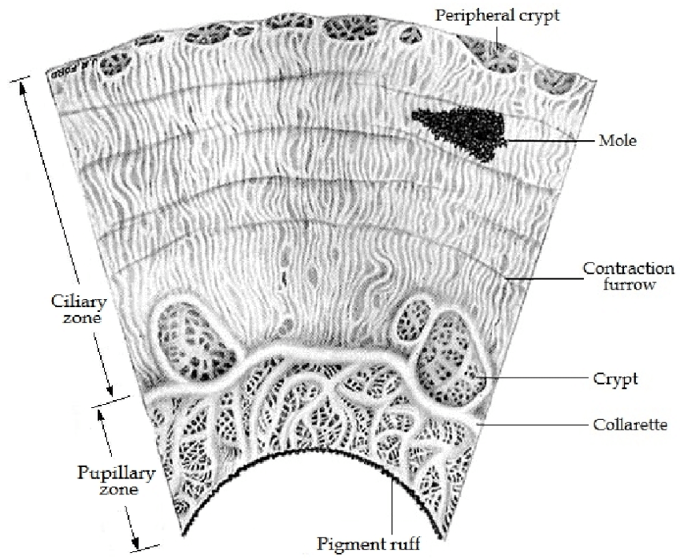

Figure 1.4 The structures of iris and their types

Besides the genetic inheritance of the irisf shape, they also parallel to one's general character features as well as health constitution. This layer of iris vodnosti has been exploited across many different fields, especially anthropology of races and morphological studies, but the results have always been blurred, as there is very little likelihood to categorize individuals solely based on their iris features because there are very wide intra- and inter-racial flaws within one race.

Researchers working in the field of biometrics and morphogenetics systematically order the types into groups based on structural patterns as opposed to color. In domestic literature, three predominant types are recognized:In domestic literature, three predominant types are recognized [24, 25]:

1. Radial Type**:** The spongy part has become more defined by series of small closely packed slabs containing healthy blood vessels. Contrary to popular belief, classification into fast or slow types primarily reflects the organization of the ventricles. Such organization may occasionally cause waves to emerge from radially-wavy patterns resulting from in-folds in the trabeculae [24].
2. Radial-Homogeneous Type**:** Education fosters tools and knowledge-based economy [25].

The first type is characterized by the presence of radially fine lines in the pupillary zone along with the strongly pigmented smoothed ciliary zone.

The second option represents a uniformly dense and pigmented circumference prevailing over the whole iris. This could be a physical type of a person or a combination of different traits from a different population.

1. Radial-Lacunar Type**:** Demarcated by the disparate stromal structure with stem cells proliferating and the intercellular spaces like leaves extending superficially to deep (Oliver, Steele, Vick, 2011). In this case, the line "her hair, long, black, and curling," ironically contradicts the imagery of the poem. It suggests a more delicate constitution, while the comparison "beaten by hail, until she was a queer-shaped mass" imitates the uneven structure of the trabeculae [25].

Despite the practicality of these classifications, their boundaries still have some limitations, especially in brand classes where the moving striations could contribute to the development of iris types characterized by heterogeneous elements in the pupillary zone. In this context, the fair iris, because there is not a well-marketed classification in most of the studies could be considered as being a subdivision of the discordances between iridogenesis.

### **Technological advances and applications of iris recognition systems**

One of the most accurate biometric identification systems is the one based on the iris recognition. This system uses the eye iris features which are unique to each individual to validate the users. This system also consists of two key subsystems: a sign-in block and a customer identification block (see Figure 1.5) [27].

The registration unit of an iris recognition system extracts information regarding the user's iris. The registration uses biometric sensor that has a particular feature of a high resolution of a iris which is scanned. Operating on the resulting images, the feature detector distinguishes amazing patterns, structure and shading that are then approximated into a digital template on a computer. The algorithm of an iris person identification system that processes an iris image is presented in Figure 1.6. Such template is than kept in the system database, which can be centralized or decentralized (e.g. when the data is encrypted and stored on the user devices only) [30].

The identification module sets itself in motion when an identity confirmation is asked. At this step biometric sensor takes the image of the iris of the person who tries to log in to the system or service. The data received is digitized and converted into a template that can be compared with a partner unit. The block executes template comparison process by itself and then compares the received template with the templates stored in the database. The system verify whether the provided iris is similar to the one of the matched iris of which the template is already in the database to hence ensure the system is highly reliable.

Figure 1.5 Biometric identification system using the iris

This way, the iris-based biometric solution represents one of the most secure and accurate options with high level of assurance and protection for data confidentiality. The technique makes it possible to identify and confirm one's authenticity on the basis of that unique physiological features and hence it is widely used in the fields of access control, banking and government.

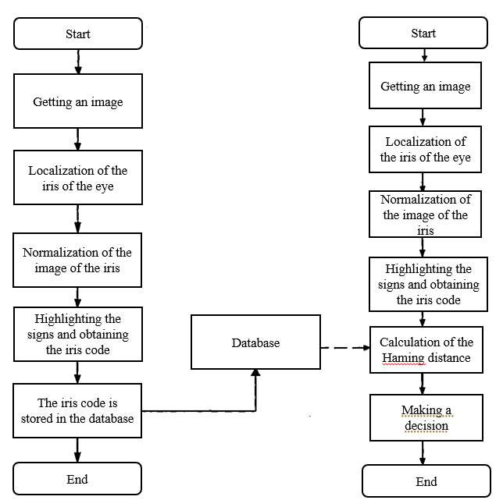

Figure 1.6 Schematic Representation of Algorithm: (a) Person Registration in the Identity Verification System, (b) Human Identification in the Identity Verification System

# **MAIN PROBLEMS OF IRIS RECOGNITION SYSTEMS**

Iris recognition systems, while offering high accuracy and security for biometric identification, encounter several challenges that impact their effectiveness and broader adoption. These systems are sensitive to environmental conditions such as poor lighting and reflections, which can impede the ability to capture clear iris images. Occlusions caused by eyewear, eye diseases, or even eyelashes can degrade image quality significantly. The high costs associated with advanced cameras and processing systems required for detailed iris capture and analysis contribute to their limited accessibility [5]. Additionally, these systems demand a certain level of user cooperation, which includes looking directly at the camera and removing glasses, and any deviation can lead to capture errors. Despite having a low false acceptance rate, iris recognition can suffer from false rejections due to minor changes in the iris or poor image capture conditions, while privacy concerns regarding the handling and security of sensitive biometric data pose significant challenges in ensuring user trust and legal compliance. Furthermore, integrating these systems into existing security infrastructures presents complexities due to compatibility and scalability issues, especially in large-scale applications such as national identity systems or airport security, which require maintaining performance with an increasing number of users. Addressing these challenges is crucial and requires continuous technological improvements, robust system designs, and stringent policies for privacy protection to enhance the reliability and acceptance of iris recognition systems in various security applications.

1. **Technical difficulties and limitations**

The accuracy of iris recognition depends on many factors, including the quality of the equipment and algorithms used. Standard metrics for assessing the accuracy of iris recognition systems are False Acceptance Rate (FAR) and False Rejection Rate (FRR) [28, 29]:

* FAR (False Acceptance Rate): The probability with which the system falsely identifies someone else's iris as familiar.

|  |  |
| --- | --- |
|  | (1) |

* FRR (False Rejection Rate): The probability with which the system falsely rejects an iris that should have been recognized.

|  |  |
| --- | --- |
|  | (2) |

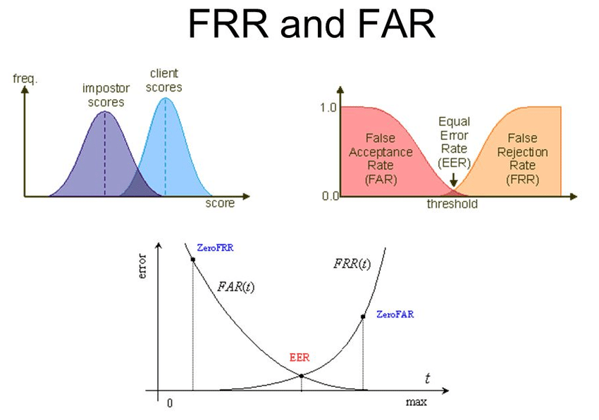

Figure 2.1 False rejection rate and false acceptance rate of a biometric verification system

Optimizing these parameters requires a balance: decreasing one usually results in increasing the other.

Moreover, the quality of the iris image which is the unique factor responsible for the performance of any kind of recognition system highly depending on external conditions such as light, distance from camera and camera viewing angle. These parameters influence to the reduction in recognition accuracy to an extent that development of adaptive algorithms is essential to effectively rendering the data output depending on mode delivery conditions. For indoor lighting the level should be between the values of 200-400 lux and for outdoor conditions figure the value much higher - 10 000-25 000 lux [31, 32, 33].

Besides the problem of linking the iris recognition system with the existing security systems; the implementation of this technology also faces a serious challenge. On top of that, blockchain is also a simple, undeniably revolutionary invention that does not only infringe on the technical compatibility of data and communication protocols, but also the administrative aspects associated with handling a bunch of different security systems. Inclusive agenda should imply standardization. To do that including security and privacy standards as a part of basic strategy is necessary. The architecture of this system comprises registration wherein biometric data are acquired, processed, a storage stage where the data must be securely kept in encrypted form, and verification stage where the sample iris is compared to stored samples in the database.

The further introduction and utilization of iris recognition systems means to address a set of problems which include to improve the systems performance qualities, to accommodate to changes within its outer on relationships with the environment, and to integrate it with other security systems. Overall, it should not only be exact and reliable, but also keep in mind about the privacy and security of personal data.

1. **Privacy and data protection issues**

A biometric iris recognition system, while prioritizing security, can inadvertently raise significant concerns regarding privacy and data protection. They have such nature of the information that is different and cannot be changed at all, and that’s why they are so popular and fragile simultaneously to the attackers. In addition to security with biometric devices, the storage of biometric data must also be implemented at the highest level of security. A common technology for safeguarding more info is encryption. Encryption algorithms like AES (Advanced Encryption Standard) and RSA (Rivest–Shamir–Adleman) just get popular place in the field. Encryption is implemented by encoding the original iris data using an encryption key, which translation is performed by a special software, and generates the encrypted part that has to be stored in a safe inaccessible to third parties [40, 41].

|  |  |
| --- | --- |
|  | (3) |
|  | (4) |

where and are the encryption and decryption functions respectively, is the original message or data, is the encrypted message, and is the encryption key.

One of the primary aspects is the secure data transfer and this call for tight control. At the transportation layer, the TLS (Transport Layer Security) and the SSL (Secure Sockets Layer) protocols are being used to protect data and information even sent via insecure channels like the internet. Hereby, the protocols initiate a secure channel between client and server, through which data transmission is encrypted, and thus, can be maintained safely [34, 35].

As far as laws and legislation is concerned, making sure that regulations such as the General Data Protection Regulation (GDPR) [34] in the European Union and the Federal Personal Information Protection Act (FIPPA) [35] in the United States are complied with by any organization using biometric data is of high importance. While the policies demand not only the security of data, but also disclosures for users at each of the stages throughout the processing the data undergoes, this is not enough. Companies have to enlighten the users on how and what purposes their biometric information may use, and they should also give the right of it to the users to access, update and delete their own data.

Issues of third-party use of data in this so-called information age poignant ethics and privacy problems. Ventures should normally limit access to biometric data, use it only to exclusive conditions previously made, and undertake security profiles to prevent its improper usage. In order to make sure that the diagram stands discrete on its own with no lack of transparency between data gathering, saving, usage, and consequently termination, its invention is more than recommended. The given diagram shall exhibit all the access points and describe how the security point can be exposed to vulnerabilities. Employing this pictorial schedule, you can easily point out crucial places of vulnerability within the data process and, of course, design particular measures to patch up the weaknesses of data protection from the source to the destination. Using this method, we can not only streamline the processes but also do work on the position of exploitation of enhanced security measures for a real use case of biometric data protection [37].

The protection of biometric data in iris recognition systems demands holistic, involving technical safeguards and rule of law compliance. The full sturdiness of biometric signals is essential to guarantee that all factors associated with biometric data processing meet the highest standards of security and confidentiality.

1. **Economic and social aspects**

Biometric iris recognition systems are significant yet costly technology that demands there is both an initial investment at application and during operation. The introduction of such systems, however, bears its price for acquisition of specific instruments, the software development connected to and the existing security press and the vehicles training as well as system testing. This type of routine upkeep and software enhancements has also a cost factor. Consequently, drawing on a certain example, the cost of a state-of-the-art iris recognition system can be from several to tens of thousands of dollars according to the number of users and the rest of the features which you need [38, 39].

Moreover, there is significance that the social implications of biometric technology adoption should be considered because the public perceptions of these technologies can be different greatly. Biometric identification can bring difficulty for some of the groups by distorting the public freedom and privacy, so commercial part and public debate exist. Transparency over data use, openness communication between the citizen and with the purpose of collecting and processing their biometric data is an important factor which helps to reduce public tension of such technologies. While on the other hand guarded data protection policies can be helpful in building up of trust.

Therefore, the extent to which biometric technologies are available to the public may also be considered a vital point. Developing countries and regions with no technological infrastructure won’t but of course will face the challenges including the implementation of biometric systems. These problems are caused by that many things such as the lack of necessary infrastructure, shortage of skillful people and cost of sophisticated equipment for biometric systems. These hurdles can very much compromise the adaptation and the most ideal use of biometric technologies in such areas. This intervention may widen social inequality even more, because the poor will not have the possibility to be instructed in biometric technology, and that, in turn will limit their opportunities to take part of the services and programs that are provided by the government and banks, such as banks’ secure transactions, banks and the government´s programs [43].

To picture telepoints, you may use diagrams and graphs demonstrated with the distribution of costs for the system and its units and include sociological surveys representing people of different groups and their attitude towards biometric technologies. The easily understandable visualizations pertaining to the economic and social effects of the implementation and operation of iris recognition systems using biometrics will help to better understand these challenges, as well as suggest solutions for emerging problems related to the development of these technologies and increasing their acceptability in society.

# **ANALYSIS OF IRIS IMAGE PREPROCESSING METHODS**

It starts with histogram equalization that normalizes contrast enabling to better see the iris structures and patterns. This step is immediately succeeded by the usage of wavelet-based algorithms, namely DWT (2-dimensional Discrete Wavelet Transform) [42, 43] that extract fine and coarse details for feature extraction by decomposing the pictures into several scales. Accomplishment of accurate iris boundary extraction is made possible through Canny, Prewitt, Roberts, and Sobel schemes [47, 48], edge detection measures. Each of these techniques tries to reveals a different structure of the iris having highs and lows on image intensity. In the end, the obtained features put neatly is done so which makes recall and matching process very straight-forward. This alternative approach integrates conventional images processing methods with state-of-the-art feature extracting techniques, thereby greatly increasing the system's effectiveness and reliability in determining individuals' uniqueness using iris patterns as a biometric identifier.

1. **Canny Edge Detection**

The Canny edge detector, an important development in image processing, introduced by John F. Canny in the year of 1986 [44], is a specific technique in the area of edge detection. It is known by its power in accurate detection of many edges inside images, which makes it a desired option for a lot of situations, such as from medical imaging to machine vision systems. Unlike other edge detection algorithms (see Figure 3.1), what makes the Canny edge detector distinct is a multistage process which confirms precise, robust, and reliable edge detection [45].

Figure 3.1 Canny edge detector

Segmentation, intricate in boundaries, is well demonstrated by Canny edge detection algorithm, and serves as the key technique in computer vision for succinct extraction of significant structural features from otherwise diverse visual element and drastically facilitating volume of data that requires processing. Under the strong vision of John F. Canny, this theory (or method) has greatly been embraced by different array of computer vision systems, where slight variations in application have come to play [46]. Canny edge detection is particularly renowned for its rigorous adherence to a trio of critical criteria: it makes sure the entire possible edges in the image are accurately detected thereby keeping the errors at the minimal level; it also provides a single position from which direction should the edge be located by experimenting with the edges’ localization in y-axis, and it attempts to find an edge that shall be unique to each detected function since most of the crude edge detector types usually result in noise-originated false edges. By means of the calculus of variations – a mathematical method used to find these functions which optimize some functionals given, Canny edge detection is based on the Gaussian filtering – which, concerning the first order approximation it is used quite often in the practical implementation, while. The Canny method has been admired ever since its introduction as one of the most effective and reliable edge detection techniques that have ever been developed by virtue of many factors. These include its incredible capability of meeting the minimum viable performance requirements and straight-forward implementation without requiring extensive expertise and training from professionals. Such traits have de facto made it the go-to benchmark method for all those seeking the high-quality and reliable outcomes for edge detection tasks This technique's robustness and precision truly make it an irreplaceable for a wide range of visual cognitive tasks. Thus, this method will always have a key position in the analysis of visual data.

Multi-Stage Algorithm of Canny Edge Detector [49, 50, 51, 52]:

* Noise Reduction: Canny edge detection algorithm starts with the filtering of the picture to smooth it and make it free of noise, cause otherwise the edges can be falsely detected. It is achieved by way of a Gaussian filter in most instances. This filter applies its role by suppression of rough edges and transient noises ensuring that, on the stages of edge finding, the results are not affected by the random image contrast going up and down. The noise that is inherent in the images tends to cause errors in the edge detection outputs and thus it becomes imperative to filter out the noise to prevent the edges from being distorted by the presence of noise. A Gaussian filter kit is convoluted with the image to obtain a smoothness. Edge detection performs better after slight smoothing of the image which is executed to minimize negative effects of noise on the edge detector. The equation for a Gaussian filter kernel of size is given by [50]:

|  |  |
| --- | --- |
|  | (5) |

here is an example of a Gaussian filter, used to create the adjacent image, with

|  |  |
| --- | --- |
|  | (6) |

It must be realized that the size selection of the Gaussian kernel is a parameter that affects the work output of the detector. The closer the relationship of size to noise, the smaller the resolution. Furthermore, the inaccuracy in the detection of the edge is going to slightly rise because of growth of the Gaussian filter kernel size. A 5×5 is the most convenient one for majority of the circumstances and the choice of the size in this case is also dependent on the situation.

* Finding Intensity Gradients: At this point, we apply a smoothing process to the image, and then we utilize a range of Sobel filters to determine the intensity gradients of the image. Hence, these filters identify luminance gradients not only in the horizontal direction but in the vertical one as well. This machine learning technique allows to provide the gradient magnitude and direction of every image point and, therefore, it displays the edges with higher precision. From this the edge gradient and direction can be determined [54]:

|  |  |
| --- | --- |
|  | (7) |
|  | (8) |

with this being the explicit formula for G, and atan2 being the inverse arctangent function for two arguments. The direction of the edge are also simplified along one of four angles, namely vertical, horizontal, and the diagonals (0°, 45°, 90°, and 135°) (see Figure 3.2). An edge direction falling in each color region will be set to a specific angle value, for instance, θ in or maps to 0° [55].

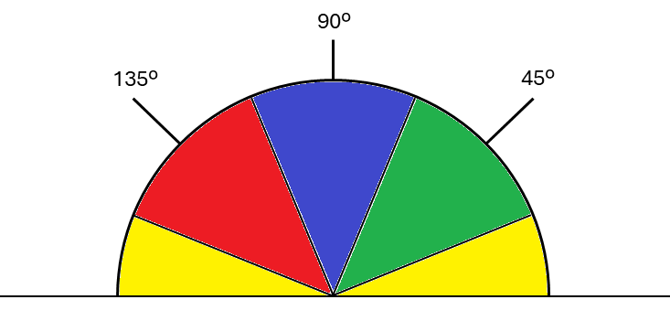

Figure 3.2 Gradient direction

* Non-maximum Suppression: Then, the next important step addresses the sharpening of those edges to make them in substance and well-defined. This process, referred to as non-maximum suppression, involves analyzing the image to eradicate with non-zero values by simply nullifying them, only retaining the local maxima to achieve that. These envelopes called maxima represents location with a quick switch from intensity value regions, very important for the definition of clear and perfect edges. This step is intended for the final image lies in avoiding the presence of a thick and blurred line in it, hence the results of edge delineations will improve in the aspects of accuracy and clarity [55].
* Double Thresholding: Next step entails the use of two thresholds — threshold for “high” and “low” [56]. This stage happens to pinpoint strong and weak pixels as well as irrelevant ones. Sharp edges correspond to the inclination rates that are above the high threshold, and these are thus directly incorporated in the concluding edge image. Low edges are those that are above the low limit and below the limit end; their inclusion in the final image is controlled by the number of strong edges they are connected to. Only edges that are non-irrelevant are incorporated from edge image that have intensities that exceed the threshold [60, 61].
* Edge Tracking by Hysteresis: In the last step the idea of hysteresis is utilized to decide which faint edges must be enclosed in the edge image. This process works as follows, if the edge is connected to a strong edge it is enhanced to strong one. With this, the algorithm guarantees the edges are being linked which improves the quality of the map edge by edges [62].

In addition to creating this algorithm, John Canny provided an edge detection computational theory, which gives a way to understand why this method is useful from a structured point of view. His theory addressed the criteria that an optimal edge detector should meet: there should be a high recall rate (all the real edges in the image should be marked), good localization (the marked edges should be in close proximity to the edge in the real image), and minimal response (each edge should be marked only once and, where possible, noise in the image should not create false edges).

## **Prewitt, Roberts, and Sobel Schemes**

The Prewitt, Roberts, and Sobel algorithms [57, 58, 59] are the rudimentary methodologies in the niche of contour detection in image processing. Among all these methods, the mathematical approach is applied to catch the brightness discontinuities from the images that help to set up the boundaries. Such techniques are a more suitable ground for image analysis applications that involve the tracking of shapes and structures, such as feature extraction in computer vision, object recognition in robotics, and more.

The Prewitt operator has its implement in edge-detection as is used alongside horizontal and vertical changes in the brightness. It determines the gradient of the image brightness at each and every pixel locate within an image. This operation is done with two 3x3 convolutions including one specifically designed to detect vertical changes in gradients and the second one specifically designed to calculate horizontal gradient changes. When applied, these masks measure the differences in pixel intensities in the east-west and north-south directions respectively:

|  |  |
| --- | --- |
|  | (9) |

The gradients detected by these filters are then combined to form the final edge detection output, typically using the formula to calculate the magnitude:

|  |  |
| --- | --- |
|  | (10) |

The Roberts Cross operator applies a simpler, yet effective method for edge detection by using a pair of convolution kernels. These are designed to calculate the gradient in the diagonal directions, making it particularly sensitive to high-frequency variations in an image:

|  |  |
| --- | --- |
|  | (11) |

The Roberts operator emphasizes edges that are diagonally oriented. Due to its smaller kernel size compared to other operators, it is less computationally intensive but may be more susceptible to noise. The edge magnitude is similarly computed by:

|  |  |
| --- | --- |
|  | (12) |

The Sobel operator enhances the Prewitt operator by placing a higher weight on the central pixels of the kernel used for calculating the gradient. This additional weighting helps to smooth the response to image noise and provides better performance under various image conditions. The Sobel operator uses the following masks:

|  |  |
| --- | --- |
|  | (13) |

This rotation of the operator improves the Sobel operator's capacity to precisely distinguish edges, as it intensifies the sensitivity to the vertical and horizontal changes of pixel values within the image. Detecting these directional changes the Sobel operator will be focused on and so will have more effective and reliable feature detection of edges. The gradient strength is computed by the same formula as it was mentioned above, and it helps the technicians achieve the best possible work while fighting against image noises and close intensity variations. The Sobel operator thanks to these fine-tuning joins more capable precision of detecting true edges against noise which makes it more useful in evaluating edges in a variety of imaging fields.

Factors Influencing the Choice of Edge Detection Scheme [63, 64]:

* Image quality and conditions play a crucial role in determining the effectiveness of edge detection operators. For instance, the Sobel operator is particularly sensitive to images characterized by low or strong contrast, such as those affected by poor lighting or substantial noise [65]. This sensitivity makes the Sobel operator adept at highlighting edges in challenging visual conditions, enhancing its utility in scenarios where image quality is compromised. Conversely, the Roberts filter is advantageous when working with finer, clearer data where noise levels are minimal. Its less complex computational demands make it ideal for experimental setups or applications that require less processing power, allowing for efficient edge detection in high-quality images without the burden of intensive computations. These contrasting characteristics underscore the importance of choosing the right edge detection tool based on specific image conditions and processing requirements [66, 67].
* Edge Orientation: For applications which calls for the operator regarding to specific edges orientations, this might particularly lead them to the Prewitt or Sobel operators because these kernels are directional [67]. For example, horizontal and vertical edge detections are more accurate using these two, which could be worthwhile for complicated indoor regions such as urban mapping or architectural plan development.
* Performance Requirements: In circumstances where speed of processing is critical e.g. in real-time video processing and case of mobile applications, the Roberts filter's minimal computational burden stands out as the most favorable option [68]. For those use cases where the precision of edge detection’s outcome severely matters, for instance in medical imaging for tumor or lesion localization, the Sobel operator’s higher level of accuracy could be the reason for its higher computational load.
* Software and Hardware Capabilities: The details of edge detection are also dependent on the existing software and machinery in place. Digitalized computing infrastructures would be able to tackle the complex calculations of the Sobel operator without problems while the hardware-based architectures might adopt the simplicity of the Roberts operator [69].

Both vectors are very useful from edge detection problems depending on their properties, Prewitt, Roberts, and Sobel. The selection between schemes takes place because of factors that may include the level of noise in the image, the desire to computer efficiently, and the direction of the edges of interest which should be focused on. Often, the Sobel filter comes ahead in trade-off between edge localization and smoothing artefacts reduction because of its accuracy and the Roberts filter may be preferable due to simplicity and high speed in cases when computational efficiency is stressed. The Prewitt operator, on the other hand, gives room for a balanced tradeoff between a simple implementation that doesn't heavily lean towards denoising.

# **IMPLEMENTATION OF IRIS RECOGNITION SYSTEM**

By means of the biometric information recognition systems, one can belong a person to the world by evaluating the identities according to the unique parameters which are issued from the behavioural and physiological characteristics of a person. Among all the systems, iris recognition is the main standout because of its high precision qualities. And thus, the iris recognition is commonly used in security identity verification programs. In this dissertation two converged image processing techniques are presented for an iris recognition system using a hybrid approach which compines different image processing methodologies to improve and ensure better recognition and accuracy. The system is set up in such precise steps, each important for the wholeness of the process of unequivocal identity (see Figure 4.1) [70, 71, 72].

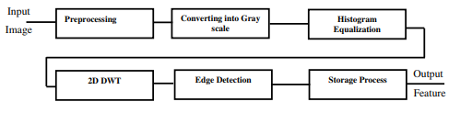

Figure 4.1 Iris recognition system

1. **Preprocessing and Iris Image Acquisition**

An iris recognition system is composed of the key elementary parts, as they are needed to be reliable in the identification system. As shown in Figure 4.2 of the given text book, the variation of the hardware configuration is due to a large number of primary components assuring availability and quality. The primary components include a lens, image sensors that can be either as a CCD or CMOS [73], processing units and related peripheral devices. These constituencies are per essence, the primary organs for the resolution of the iris high-graded clips/pictures that are needed for the precision of the system.

Figure 4.2 Hardware part

The main software part of forthcoming iris recognition system that is depicted in Figure 4.3 can be broken down into several stages, all of which are essential for the right recognition of iris images. At the preliminary stage, the iris image is captured by the related system; afterwards, image filtering follows which enhances the image through reduction of noise and improvement of contrast; localization then implies detection and isolation of the iris from the other parts of the eye image; normalization, the subsequent stage, then standardize the iris region and; feature extraction composed of that pattern identification and encoding of the iris are also part.

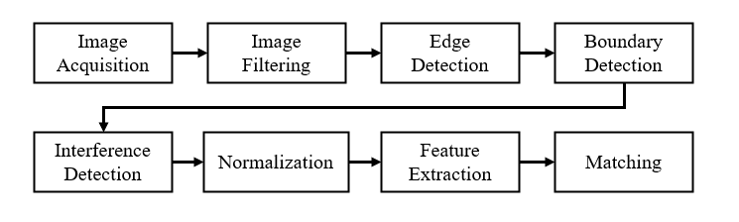

Figure 4.3 Software part

In a fully integrated iris recognition system, the software is typically divided into two main subsystems: the attendance system in order to check in. The enrollment system divides into three components: capturing individual's iris data, processing it into biometric templates, and storing templates into a biometric database. The major part of this paper dispels the issue of identification system , which is on pairing a new eye imaging with the existing templates allowing for either verifying or identifying the person.

John Daugman who is the father of iris recognition technology accepted the terrible impact iris image quality has on the performance of these systems. It was stated by some scientists that it could be seen in massive testing wielding over 9 million personal number that all the individuals were truly recognition without any false alarm, but sometimes the quality of the iris image caused the poor similarity calculations. This stage showcases the key role that preprocessing plays in this recognition system of the iris. Preprocessing improves image quality, which is critical to have features properly extracted that represent the iris structure and reduces the possibility of identification flaws during the ensuing phase [56, 62, 86].

That is particularly crucial in order not only to obtain high precision in identification but also to increase system dependability and stability when the latter is working in factors like the complicated surroundings or changing illuminations. The integration of reliable software systems equipped with advance software powers coupled with topnotch hardware multiplies the capabilities of biometric devices by giving rapid, dependable, and precise identification capabilities, which find wide acceptance in security-sensitive applications across different sectors. The images are then subjected to a series of preprocessing tasks [56]:

* Image Normalization: The contrast and lengths of the image are fully qualified by the standard intensity range and size used for easier processing steps.
* Image Enhancement: Examples of using such techniques as sharpening and contrast adjustment so you will be able to distinguish the patterns of the iris' in the end picture.
* Resizing and Truncation: Filters are imposed to the iris portion of the images to separate the iris from other structures of the eye. Here both the boundary detection of iris and the extraneous portion of image cutting is performed, and subsequently, the rescale of iris image to the require input standards of the upcoming processing steps is done.

These procedures of image enhancement guarantee that the iris images are adequately touched up for the following feature extraction and recognition processes, and thereby heighten the system’s overall reliability.

1. **Grayscale Conversion**

Color images conversion to grayscale in digital image processing is among the critical areas that have witnessed a major revolution through a wide variety of exceptional innovative techniques. These three techniques were made to resolve the particular issues of retaining the quality of both the perceptual and the structural components of the color image when it is presented in grayscale. Following the presentation, we focus on six contemporary research studies that illustrate different methods to approach grayscale conversion. We also mention the importance of adapting to different imaging conditions and the different applications use.

A cutting-edge technique based on the Lab color space, which is well-known for its accuracy in human color perception, is also being explored in the current literature to refine grayscale conversion. This technique involves the addition of a correction term which is designed for the proper handling of chrominance components, that vary spatially. The algorithm starts by computing the high pass filtered copies of all three Lab channels. It then joins the high-pass data from both the chrominance channels ( and ) into a single signal that contains all the information of those high-frequency chrominance. The benefit is that gray values adapt in a dynamic way with the color in the original image, that has different grayscale values with respect to its local neighborhood, thereby enhancing the visual quality by taking into account the original color differences in grayscale [71, 72].

Sentence one focuses on the color handling of fluorescent colors which are difficult to manage in color reproduction since they are saturated and vibrant. This technique entails moving the source color image into the uniform color space and then, calculating the target differences. The least square optimization method is then applied to achieve the optimum gray-scale components. However, this process is resource-intensive in that it requires a lot of both time and memory. Nonetheless, its preservation of color lightness gives it a reliable solution especially in images where the brilliance of the colors is very important. Nevertheless, it does not provide impressive results in such dense ranges of luminance, which are mainly characteristic of natural scenes, where the variation is quite large.

Furthermore, a proposed method of improving the comprehensibility of colors for color-deficient viewers is through the re-coloring of images so as to enhance their accessibility by the viewers, while also avoiding the introduction of visual artifacts. Dividing the original image into a series of layers with varying Luma values is used. The resulting grayscale layer, combined with the original layer, is matched to preserve excellent contrast. Besides these two types, it too uses constraints for brightness adjustment in the luminance bands that are fixed by the chrominance limitation. This is where this technology really comes into play; particularly for images where luminance consistency as well as having both is essential. It is good in images with certain type and could serve as a trend for others that the way it in fact works indicates its wide usage in different practical situations.

To go further, another research paper carries out studies applying a newly-developed method that utilises a multiscale approach to restore the details of texture that are usually lost during the modeling process through the traditional method. A multi-scale version of this method, on applying diverse selection of filters to each scale of image, preserves the intricate details across different resolution levels which it ultimately suitable for high-quality applications like in medical imaging and satellite images.

Another new algorithm focusing on combining machine learning features has been also invented to improve perceptual similarity in grayscale images by using the semantic content of the colored image. This method exploits the knowledge of a dataset of color pictures and their corresponding gray-level equivalents along with locality ratings with respect to quality and faithfulness. The model is trained on this data to achieve optimum conversion parameters for different images and scenes.

Last but not least, an adaptive filtering technique tailor-made in line with the content of the image; whether the image is a of a scenery or without text becomes the important thing. With this content-oriented method, you can adapt parameters dynamically, optimizing the photo conversion for the best image quality particular to the content i.e. the type of image or video frame.

Such process changes the three-channel color image (RGB) destination into a single channel image where each pixel represents different shades of gray. This is typically accomplished using the luminance component (Y) of the color image calculated as [74]:

|  |  |
| --- | --- |
|  | (14) |

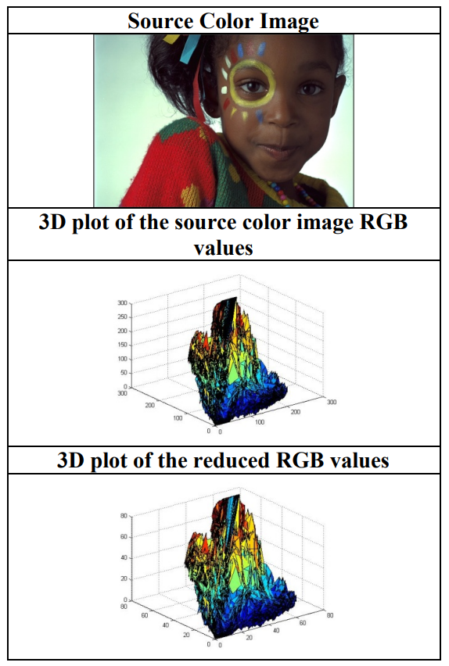

Figure 4.4 Comparison of main image RGB and resulting RGB.

## **Histogram Equalization**

Adaptive Histogram Equalization (AHE) is a sophisticated image processing manner, which is aimed at improving the contrast of pictures. Contrary to regular histogram equalization which transforms the entire image based on its global histogram, AHE addresses areas of an image where contrast needs to be improved. The localized method of enhancements permits in fine tuning ,and is found to be very effective in areas of significant variation in brightness, for example in medical imaging and satellite photography.

AHE is working with the image being split into different little textual areas called by “tiles” [75]. "Due to the fact that AHE works independently in each of these areas, the sub-regions' pixels intensities histogram is computed and then used for remapping pixel intensities in these specific areas. This procedure makes it possible to control the fine details and adjust them separately for each region as they might be missed with global approaches.

In a scene where details and highlights are of utmost importance, AHE can offer an even look throughout the entire image. Nevertheless, this method may cause some noisy over-amplification when most of the region of an image is nearly homogeneous. This problem is addressed by CLAHE algorithm which is one of the variations of HELG [75]. CLAHE stops the contrast enhancement at a certain level due to the clipping of the histogram before the cumulative distribution function calculation. Hence, the clipping function helps to suppress the amplification noise and to avoid the over-emphasis contrast in the uniform areas.

The process of AHE involves recalculating histograms for each tile and applying a transformation function to equalize the histograms. If represents the original intensity values of the pixels, and represents the new intensity values after equalization, the transformation function can be expressed as:

|  |  |
| --- | --- |
|  | (15) |

where is the probability density function of the pixel intensities within a specific tile, and the integral computes the cumulative distribution function from the histogram.

In digital image processing, particularly when enhancing contrast through techniques like Adaptive Histogram Equalization (AHE), MATLAB proves to be an invaluable tool for implementation and visualization. Below, we explore how histogram equalization is applied to an iris image using MATLAB, highlighting the practical application of the technique discussed earlier.

Here is a MATLAB script used for applying histogram equalization to an iris image, enhancing its contrast for better visual clarity (see Figure 4.5) [69]:

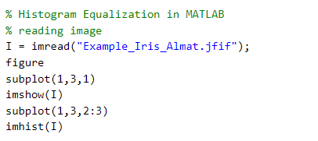

Figure 4.5 Histogram Equalization in MATLAB

This script performs the following tasks [75]:

* Image Reading: The grayscale image of an iris (Example_Iris_Almat.jfif) is loaded into the workspace.
* Display Setup: A figure is created with a grid layout for subplotting.
* Image Display: The original image is displayed in the first panel.
* Histogram Display**:** The histogram of the image's intensity distribution is displayed in an extended panel spanning the second and third sections of the grid.

The output from this script is a figure with two subplots (see Figure 4.6):

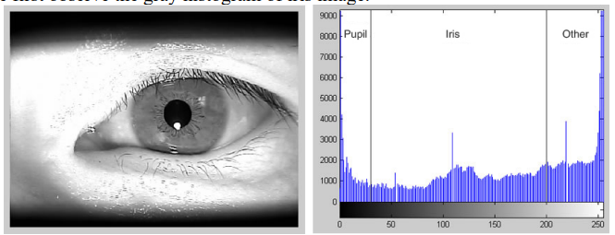

Figure 4.6 Output (Histogram Equalization)

* The left subplot represents the first grayscale image which a photograph of an iris is. The resulting image view allows to detect the image quality and an inhomogeneous distribution of brightness without any processing.
* The top (right) subplot displays the histogram of the gray-scale values in the image. In this histogram,thedark nodal which corresponds tothepupil part andthe mid-tone regionis the iris part can be observed whereasthe brighter areas around the eye.

## **Application of 2D Discrete Wavelet Transform (2D DWT)**

The Discrete Wavelet Transform (DWT) is a key tool in the domain of digital signal processing, which is specifically used in image analysis and video analysis [20]. Its advantage of providing both frequency as well as spatial localization makes it more effective in dealing with signals that are not stationary and parameters which can change over time, contrary to the conventional Fourier Transform that offers frequency information only. The wavelet transform substantiates the effectiveness of DWT because of its capability to break down the signal into a group of highly transient wavelets that differ in frequency and duration. This multi-faceted strategy gives a more precise approach to processing data which is especially relevant for imaging watermarking, signal compression and noise reduction.

The core operation of DWT in image processing includes splitting the image into several images of hierarchical sub-bands, each simplifying specific frequency details. The primary lines which is a manifestation of the interaction process are LL (Low-Low), LH (Low-High), HL (High-Low) and HH (High-High). Each of these bands represents different aspects of the image [20]:

* LL Sub-band: Preserve the almost similar retention of the image data with low frequency components on both horizontal and vertical directions identifying the major of the whole image signal. It signifies finer image detail quality in the continuum.
* LH Sub-band: Conveys the information about the objects which extend more in vertical plane with fused details of more horizontal oriented components, works well for edge and other kind of vertical features.
* HL Sub-band: Includes the description of the features with a great amount of lateral data, which are especially significant for recognizing horizontal patterns within the picture.
* HH Sub-band: Meant to convey high frequency components in both axes and thus much better show the smallest details present in the source.

The LL sub-band is particularly important as it has many detailed information and consists most of the energy components of the image. The image structure the coarse representation of the image completes can be determined using the LL sub-band. This band is not too much influenced by changes and is generally taken as the starting point for breaking up further into more detailed time- frequency into the rhythms of multi-level wavelets (see Figure 4.7-4.8) [76].

In digital watermarking, DWT disposes a watermark into the high-frequency sub-band components (LH, HL and HH). The bands are also selected for the purpose of compromising the minimum possible losses in the high frequency regions which are least perceptible to human eyes and therefore avoids degrading the visual standard of the image yet makes the marking robust. The coding process usually involves changing the 'wavelet coefficients' within the 'wavelet bands' to store watermark information, which can be extracted or detected bypassing the original image. This ability to detect watermarks directly from the images without the necessity of the original picture brought the application efficiency and reliability of the DWT to a higher level in information security.

DWT offers several advantages over other transformation techniques, particularly in terms of computational efficiency and better localization properties [20]:

* Multi-Resolution Analysis: DWT is a method way of inspecting the image at different levels or resolutions that gives chance of picking the precise local and global image features.
* Spatial Localization: In contrast with other transforms that might take the effect of local alterations and show this along the domain of transformation everywhere, DWT has better spatial alignment, allowing the local-image features manipulation.
* Robustness in Applications: DWT’s superiority to deal with high frequency contents nicely as it is what makes it most suitable to computationally intensive applications such as compression and noise removal in which preserving the quality of the original signal is very important.

Figure 4.7 Sub-bands are formed after applying a 1-level discrete wavelet transform (DWT).

Figure 4.8 DWT of an image that is conducted using 3-level pyramid as a decomposition technique.

## **Edge detection**

Edge detection in iris recognition is a process of locating points along the vertical or horizontal axes in digital images where the image brightness changes sharply or, in technical terms, where discontinuities happen in the pixel intensities. These interruptions are indeed of utmost importance as they are used by the software for mapping out the unique curvatures of the iris, for example, rings, furrows, and freckles.

Key Steps in Edge Detection for Iris Recognition [77, 78]:

1. Preprocessing: First there are preprocessing steps that aim at enhancing the quality of the iris image; preprocessing is a requirement before edge detection can start. To achieve this, the noise can be removed and the contrast improved while the overall image is normalized to deal with any inconsistencies such as light variations that may be present.
2. Segmentation: The eye is segmented from the rest into the iris. These separate the circumference walls of iris both from the inside of the pupil (the inner boundary), and from the other side of the white of the eye (the outer boundary).
3. Edge Detection Techniques:

* Gradient-based Methods: Such methods as Sobel, Prewitt, and Roberts techniques estimate the gradient of the image intensity at every pixel, which reflects the edges where the gradient (on the image) is higher.
* Laplacian-based Methods: They are basically the second-order partial derivatives of an image finding a level where the derivative has zero value (zero-crossings).
* Canny Edge Detector: This is a popular technique in iris recognition as a noise reduction is good and a detection precision depends on the quality of the original image [79]. The Canny algorithm employs a multistage algorithm whose mission is to detect the wide range of edge in the image.

1. Feature Extraction: The next step is to find the edges of the iris, for which other features can be extracted specifically from these edges. The above characteristics are made up of the individual's iris template, which is subsequently used for the process of matching and verification.

Iris edge detection faces us with a few different obstacles, such as occlusions of the eye which originates from eyelids and eyelashes, then the distortions which are caused by reflections that can hide the iris patterns. Furthermore, the images that use intensity, lighting conditions and resolution issues can pose huge problems and in the way it identifies iris features that are very important. The problem of uneven illumination and image quality can be solved by applying adaptive histogram equalization and illumination correction techniques which help in image preprocessing prior to edge detection. Also, snakes (active contour models) offers a type of dynamic algorithm to accurately track on iris’s complex and irregular boundaries even in suboptimal conditions. Spectral imaging with multi-spectral imaging is another important benefit because the images are captured at different wavelengths, therefore, more information is exhausted that the weaknesses of traditional imaging systems have problems with.

The accuracy and capability of iris recognition systems are gauged on how well edge detection is carried out. Hence, edge detection is directly proportional to the performance of an iris recognition system. Precision of iris edge detection enables a subsequent step of feature extraction, which is performed based on the unique patterns of the eye's structure, considering that templates are created based on these features for matching and identification. This accuracy should be also among the crucial issues, because such a high level of reliability provides a necessary condition in a high-security application as a control access, border security and secure transaction verification. Technology of iris recognition is currently increasingly perfecting the system architectures using edge detection that in turn bring the field of biometric device development to the next level of secure and efficient systems design. Such progress signifies the necessity of classic image processing approaches in addition to other direction of development of more sophisticated strategies to maintain the security level of all kinds of applications situated in different sectors.

1. **Feature Vector Storage and Organization**

In biometric iris recognition systems, where feature vectors are a look of an iris in the form of lines or edges, for example in that stage lumber structures is the place where the field named as Organization and Storage of feature vectors. Characteristic vector in primitive terms of iris recognition is something which has been defined in the form of numbers or symbols attributes derived from the digital image of person's iris. The vectors are atoms that seek to immortalize the distinguishing features of the iris, like ridges, furrows and uniqueness marks which is an important parameter in authentication and identification of individuals.

Mostly, the process engages in the capturing of iris image by means of which the preprocessing steps, for instance, localization, normalization, and enhancement, which improves the image quality, are implemented prior to feature extraction. First of all this image is a subject for algorithm calculations, typically wavelet transformation and other edge detection techniques, that recognize and categorize the details of the iris like shape, pattern, color, and so on. There are two key ramifications of this step: a particular feature vector or data points that summarize the inner content of the iris.

Upon extraction, the feature vectors whether they are the audio files or images must be organized in a way that simplifies their retrieval and comparison. This task is typically employed as an element of the database system which in turn is able to operate with large volumes of data in a quick and efficient way. Here are several critical considerations in the storage of iris feature vectors [79]:

* Database Design: Database design is perhaps the most crucial step of the project. It has to be optimized for the functionality that is peculiar to biometric systems, namely, the extraction, searching and comparison of that vector feature either against the one or all known samples. Such action should take place with a high degree of timeliness so that instant response to notification and verification systems is possible.
* Scalability: The increasing number of the users in the database should lead to its scalability in such a way that the performance will not go down significantly. Scalability makes sure that the system is able to commercialize large-scale deployments usual in national security applications for example, airports, and other domains requiring the systems that can handle biometrics solidly.
* Security: Specifically, such data is very important and to secure it is not optional. A message encryption and secure access techniques in data protection from unauthorized access and penetrations are the techniques that must be used.
* Redundancy and Backup: Providing reliably sources and storing backups is a critical issue, therefore, redundancy mechanisms and regular backups should be implemented to ensure the integrity of data and availability. This becomes very essential in data recovery protocols during the scenario of disasters to keep data safe in case of data loss.

The way the features vectors within the storage system are logically fixed affects a lot to the general operation of the system. Efficient indexing mechanisms are essential to speed up the retrieval and comparison processes:

* Indexing: In doing so, we can achieve a significant boost in accuracy by utilizing correct indexing techniques that can ultimately improve vector lookup during the pattern matching process. Signes should be tailored taking the repeated searches and transactions that the system will execute mostly into account.
* Clustering: Clustering the feature vectors having similarities among themselves enables acceleration of searches, mainly in verification and segmentation instances, where a query is asked to be queried against the data banks holding millions of features.
* Data Compression: Using feature vectors compression technique can help in perfecting storage space utilization and at the same time higher the transmission speed but the quality of information lost will not be significant. Efficient compressions that help in space saving can be a boon when such end result in better performance.

This sequence of operations is made up of steps that are identical to one another. However, their difference is that they develop upon the earlier step and provide more defined features. This helps with iris recognition, which gives accurate results and discern with no problems. This intricate process is not only going to assure the technical robustness of the system but to put some his applicability in real-time where it is required that the biometric identification is done quickly and accurately. The following chapter shapes the prerequisite ground to comprehend the nuanced architectures and procedures to design a compound iris recognition system.

# **RESULTS AND ANALYSIS**

Applying iris recognition system to different images of different types ensures that the effectiveness of each step is confirmed. The stringent testing is of great importance to make sure that the systems components function as they should do and bring about the desired effect of precise identification. The area of result visualization is somewhat important since it not only solidifies the application but emphasizes the contribution of each preprocessing, feature extraction, and edge detection technique on the system’s performance. The evaluation involves the use of various types of images as a medium through the system so as to focus on the aspects of how each of the methods lead to better, clearer, sharper, and distinct images, which are the basic requirements for any identification process. This technique allows us not only to adjust but also to bring out the incongruity in each method resulting in further optimization. The same detailed analysis and the comparative review help in establishing a resilient framework that can be effectively used in arduous conditions, and eventually delivers high performance all the time independent of the imagery conditions and the iris types.

1. **Presentation and analysis of the results obtained from testing the iris recognition system**

At this crucial initial stage, a sequence of processing transformations takes place, which results in the best image resolution and vision of the iris on its peculiar size, which is a key aspect for recognizing the image. The formation stage is characterized by the application of filtering techniques that focus on boosting the visual sharpness and the valence for that to succeed the specific features will be more distinguishable. The prime function in this part is for delineating the edges of the iris that is highly precise, a mission that involves fast edge detection algorithms making a significant differentiation between Iris and the other bony parts such as Sclera and Pupil [80].

Furthermore, noise reduction algorithms are sought to be done with the picture in order to take out any difficulties that could come about due to digitization artifacts or light differences which could hide the smallest features of the iris. Besides, the binary image is re-sized to standard dimensions, an operation which as well presents the uniformity characteristic of the system, but also enhances the effective operation of a follow-up analysis. This process uses fine-tuned resizing algorithm to traits that are crucial for the identity of the iris, preventing the loss of any worthy data during this procedure. What this implies is that despite the fact that preprocessing methods may lead to minor changes in the original image, the overall quality will be enhanced which is seen in the presented Figure 5.1, where noise levels have been greatly reduced and the iris boundaries look clear and defined. This rigorous beautification of iris images constitutes a strong base for the feature extraction stage that definitely perfects the system in endowing it with more accuracy and reliability in iris recognition.

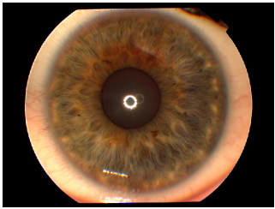

Figure 5.1 Restore original color picture

This fundamental procedure of the iris recognition involves changing the original packed color visual image of the iris into a grayscale image, and Figure 5.2 deeply spells out this. The color image conversion to grayscale as a crucial preprocessing technique reduces the technical complexity of image processing and simplifies the chromatic information transformation. The essence of this transformation is to discard the structural color information and keep the luminance/intensity only, which is the only thing the system should attend to. The primary attention should be paid to the iris's texture and structure detail which is the actual feature used for the iris identification. Framework of its artwork was the simplicity and black-and-white images afford the greater feature extraction and edge detection, since color variations do not attract more attention for shape and pattern analysis. This step improves the system's detecting skills, thus, delving into the intricacies of the iris patterns, which are vital for biometric readings that are accurate and reliable. Moreover, taking the image into the gray scale aims to match the data for different illuminations and cameras, and thus to attain the performance stability in search for and the interpretation of the system features. The core of this method is computing a weighted average of the R,G,B (red, green, blue) values of every pixel and allocating this result as the new pixels intensity in the grayscale version, which simply retains the brightness values and disregards the hue and saturation information. This approach, which is beyond the standard similarities observed in the data load, thus maintains the necessary visual intelligibility with fewer data for quicker and more efficient iris recognition systems.

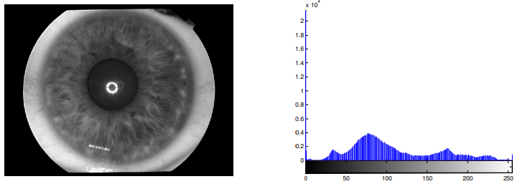

Figure 5.2 The primary color image is being interchanged with the gray scale image

By the contrast enhancement of the Iris recognition process, two distinct enhancement techniques are used to greatly enhance the quality of the Iris images. The first approach, including Histogram Equalization, is employed in order to highlight the contrast and details in the iris images, which is vital for the fatigue-free extraction of unique iris features. The way how it works is by spreading out the most common intensity values instead of the usual storing the pixels with the highest intensities which results to higher global contrast. Therefore, such kind of enhancement is particularly helpful on those pictures whose are similar in lights intensity and those where the contrast is poor allowing to recognize the iris details better. The power of histogram equalization convincingly exemplifies how image equalization is improved after it in Figure 5.3; the target images bring clearer images and sharper details. This better resolution not only increases the accuracy of feature extraction, but it also ensures fewer possible errors in the subsequent stages of the recognition steps. As the dynamic range of the grayscale values is being optimized, the histogram equalization technique guarantees a better uniformity and prominence of the iris patterns which is a necessary pre-requisite for the successful operation of the feature detection algorithms used in the next step. Through this step, the iris images will be ready the in-depth analysis, effectively allowing the biometric system to identify and verify people by their distinct iris patterns.

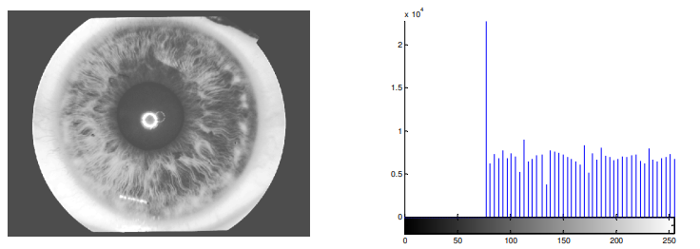

Figure 5.3 Image enhancement is achieved though of with the help of histogram equalizing

Over the first step, Histogram equalization will be utilized to see that the subsequent step, adaptive histogram equalization (AHE) [75], performs a further refinement towards the Equalization of somehow vague iris images. Compared to conventional image restoration algorithms that use a single correction parameter, this advanced technique is more robust because it adapts to the local characteristics which are different in various areas. AHE performs by revolving around the the use of an image to divide the images contextual areas or tiles into pieces and then applying the histogram equalization to each of these tiles independently or separately. This localized strategy permits to move the brightness challenges and show the contrast features in specific parts of iris which is important for those images affected by imbalance of brightness and overexposure.

The greatest benefit of AHE as far as setup of the iris recognition is concerned is that it focuses on the finer details such as the textures of the iris that are super important for accurate owner recognition. These occurrences which could have been ensconced in the banal uniformly bright or dark areas then emerge more clearly after the application of adaptive histogram equalization. Specifically, spike gradient descent-based method is seen in Figure 5.4 to mainly increase the visual quality and match the iris image by using the equalization. At the first level of image enhancement, the images demonstrate a clear change in the amount of detail visibility, where the edge and iris features are now more defined and easier to identify in subsequent processing attempts.

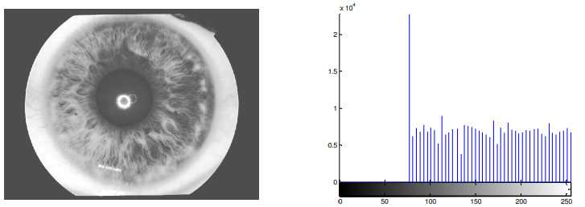

Figure 5.4 Image enhancement is achieved though of with the help of histogram equalizing

AHE advances local contrast in iris regions ensuring that detailed features are brought out thus AHE not only contributes to the reliability of the iris recognition system but also assists in the reduction of error rates associated with poor image quality. This ultimate property is achieved by specifically attuning the iris recognition system to the diverse nature of images that come under its purview. Consequently, it enhances the effectiveness of the iris recognition system in a wide range of applications.

The 2D Discrete Wavelet Transform (2D DWT) is a very important tool in the Iris Recognition process, which decompose the iris image into different frequency components, resulting in the extraction of some features that are crucial in the identification step [81, 82]. As the 2D DWT is applied, the image takes different sets of coefficients which represent the different characteristics of the image data while under the transformation. These coefficients relate to several resolutions, first the course then more detailed levels of the eye. This process could be used to diminish the size of the image data, leading to a reduction in the data volume, depicting significant features and eventually decrease the processing time as well as achieve efficiency.

In our implementation of the 2D DWT, the output image is spatially compressed in order to eliminate any unnecessary redundancy that might render the significant features of the image unusable for the recognition process as Figures 5.5 and 5.6 both shows. The process utilizes several wavelet masks; however, for our purposes, two specific types of wavelet transforms were chosen for their effectiveness and efficiency: the identification of the wavelet transform masks which are Harr and Db2. These types of masks are usually used in iris extraction because they can get the high-quality features of the iris region while preserving its precision with very minimum distortions.

Figure 5.5 There are two stages of two-dimensional Harr discrete wavelet transform

The Harr wavelet [20], which stands out for its easy way of implementation and speed, is suitable for detecting edge like structures from the iris which is essential for identification of different human eyes. On the contrary, the Db2 (Daubechies) wavelet, having a bit more complex and smoother properties, allows the processing of the fine fluctuations in the iris structures to happen faster. Optimal usage of these wavelet transforms together provides a comprehensive selection of features, that covers the most obvious and even the smallest ones, helping the system to better match and analyze irises of individuals. The special wavelets mentioned above in the 2D DWT make a great contribution to the robustness and reliability of the stage of feature extraction. Therefore, it ensures that the iris recognition system performs accurately in all possible conditions.

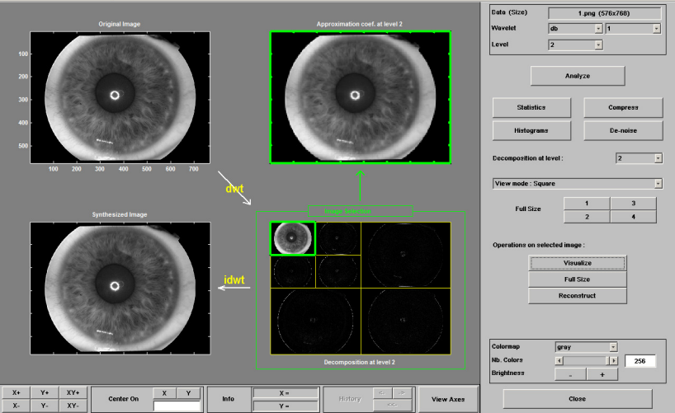

Figure 5.6 There are two stages of two dimensional Db2 discrete wavelet transform

A critical aspect of edge detection in the iris recognition process relies on various algorithms to unravel the complex structure of the iris accurately. These, for instance, are the Canny, Graham Roberts, Prewitt, and Sobel edge detection techniques [85], with each of them making an inimitable contribution in the part of feature recognition. As can be seen in the Figure 5.7, panels of (a), (b), (c) and (d) demonstrate the result of employing these various edge detection techniques to the same iris images.

What Canny edge detection is good at, as shown at the panel (a), is its ability to effectively detect wide varieties of edges in images without being misled. It utilizes a multi-stage approach to detect edges, in which a Gaussian filter is implemented to suppress noise, in addition to locating intensity gradients of the image and then tracing edges using hysteresis thresholding. This overall method is holistic in nature and hence can accurately express exhibits more than the other methods. This leads to an enhancement of the fine details of the iris structure which then become highly significant when creating feature vectors.

However, the results illustrated in panels (b), (c), and (d) by means of Prewitt, Roberts, and Sobel detectors, near similar patterns can be noticed. These are the categorically linear gradients with edge detection modules that are least complicated focusing on light variations to identify edges. Prewitt and Sobel methods in specific, can be said to reinforce horizontal or vertical edges through a process of directional filtering, whereas Robert’s approach is a simple but less computationally taxing slanting edge detection method.

Such consistency is since the Prewitt, Roberts, Sobel comprise first-order derivative filters, making them insensitive to finer details in contrast to the Canny filter. Nonetheless, they suggest the considerable boundaries of the iris more quickly and accurately than alternative methods. Interestingly, these techniques are sufficiently accurate for cases where the high pace catches the most important things.

The unique feature of the Canny method that cannot be matched by any other solution is its ability to reveal the tiniest and most complex details of objects, which makes it the best in those cases, where absolute precision is required. Its efficiency in the recognition of iris is founded in its capability of extracting the needed feature patterns that must contour even the closely resembling irises such that the iris recognition system becomes stronger or more reliable and secure in general.

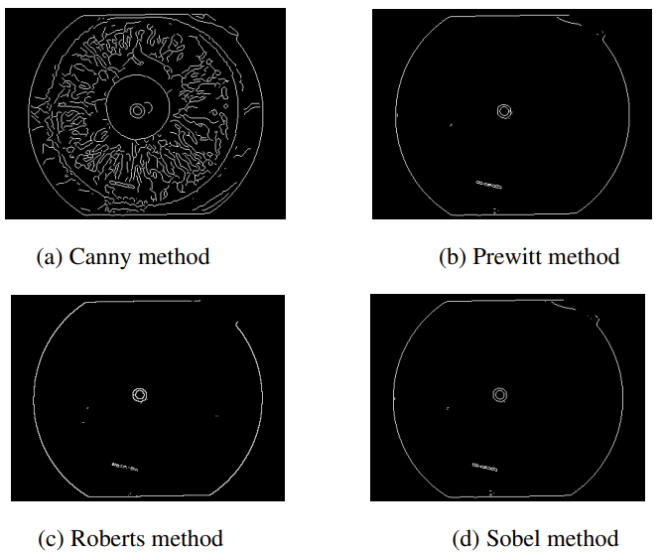

Figure 5.7 Edge detection applications

The evaluation of several edge detection methods, Canny, Prewitt, Roberts as well as Sobel, which are applied within the iris recognition system, confirms their different potential for edge detection. Figure (7)(a) which displays Canny edge detector is special because its result is so precise and full of details that it would be ideal for applications where feature extraction needs fidelity. Its robustness, which results from a rather thorough edge detection algorithm that covers noise reduction, gradient calculation, and more accurate thresholding, becomes a way to reach the finest details that are important to achieve iris recognition templates with precision and truthfulness.

On the contrary side, the Prewitt, Roberts, and Sobel strategies, while giving comparable results as represented by Figures (b), (c), and (d), are more focused in the goal of getting quick results and speed. These methods are comparatively easy to implement, and their speed of execution is better suited for the real-time applications where processing speed is essential.

The analysis concludes that an edge detection method is very important in the functioning of an iris recognition system, for it can drastically affect the system' performance as far as the accuracy and reliability of the outputs are concerned. Hence, the task of selecting the proper edge detection technique adjusted to the critical needs of the system, either to capture details for high-security purposes or to ensure speed for real time processing, assumes a significant importance in increasing the efficiency of iris recognition approaches. The paper provides a framework comparison which helps in selecting the appropriate system as well as easier to understand the effect of edge detector on biometric recognition systems.

1. **Visual aids and explanations on how each processing step affects the results**

This part, in detail, describes the step by step transformations used at each step of a process. It shows how these contributed towards better system accuracy and reliability. With the real iris image acquisition at start, you can view under various conditions how important enhancement strategies are in imaging process. The pictures really emphasize critical issues like different lighting states and occlusions, which are meant by the models of preprocessing.

The first step, referred to as preprocessing, is of crucial importance in the process of normalization and enhancement of the iris images, as it is demonstrated via before and after visuals with histogram equalization and adaptive histogram equalization techniques. These methods are found to be effective in producing good contrast and improving the brightness of the image, which in turn make the iris patterns more visible and consistent regardless the variations in different captures. The visual graphics here are histograms along with the overlay graphics that just well describe the enhancing of dynamic range and reduction of shadows and highlights which greatly assist in iris identification and segmentation.

Moreover, it continues with the explanation of different edge detection algorithms by showing the conspicuous edges identified by each method in a visual aid. The graphical illustrations are very important in the realization of the fact that more advanced methods such as the canny edge are preferred due to the reason that they are capable of pinpointing the thin iris details with utmost accuracy. This is what is required in order for one to have a good feature extraction system. The edge detection impurities carry the purpose of demonstrating how inaccuracies in edge detection can result into errors in feature extraction and may compromise the system efficiency.

The sub-step of observation is visualized itself by using diagrams that illustrate how the wavelet transform decompose the iris image into frequency sub-bands. Each band may be viewed as an element of iris structure representation, forming a comprehensive template consisting of general as well as minute details that are important for unique identification. Visual aids illustrate the multi-resolution feature of the wavelet transform. The subsequent decompositions first map out the most general features and then get into details necessary for separation between irises.

On this part, images of iris templates coming from different people are used, presenting the distinctness of each generated iris pattern based on the selected approaches. Such comparisons for instance illustrate the ability of the system to discriminate and show the distinct nature of every purification step that is required for achieving the differentiation.

This separate part of this chapter shows each step iris recognition in detail and uses graphics to illustrate the transformation of the biometric data from raw images to purified templates. The graphics are added with detailed explanations, which demonstrate how each of the processing step plays a part in improving the accuracy of the system as well as enhancing its reliability thereby, offering an all-encompassing understanding of how sophisticated image processing algorithms can be used to achieve biometric identification. Since the integrated approach puts emphasis on both theoretical and practical aspects of the biometric systems, it not only broadens the academic discussions around these systems but also can be seen as a practical guide for improving system design and implementation.

# **CONCLUSION**

This dissertation paper delivers a detailed view of introducing and advancements of iris recognition technology, which mostly relies on hybrid techniques of histogram equalization and wavelet modulations. This research delves into the fact that biometrics significantly contribute to the improvement of identification systems, clearly introducing this matter as an important part of the security protocols system across the range of spheres.

The combination of histogram equalization and wavelet transforms in iris recognition systems is an example of an operation which has been proven highly successful. The histogram equalization is a way that the visual quality of iris images is improved by increasing the contrast so that the fine structure details are pronounced/elicit more provide more information than a comparison through macroscopic features of the iris. This need for precise texture and pattern recognition has necessitated such an alteration for systems which require patterns to identify products. Wavelets introduces another level of detailing using the measure of frequency to decompose the image into components, which later enables capture of both global and local features of the eye required for iris identification. This approach works on two processes to make the iris recognition better than using single software application to provide the feature extraction process and to create the robust, and adaptable system that can run under diverse operational conditions with high accuracy.

Assessing the hybrid iris recognition system indicated a striking upswing in the dependability and the level of accuracy when compared with the traditional methods. The system showed the marked up of considerable true acceptance rates which identifies the characteristics for the biometric system's performance, thus becoming essential in checking the vulnerability to attacks of high-security facilities. The novel biometric technology is aimed at overcoming the historical drawbacks of iris recognition systems that were particularly affected by different lighting and weather conditions and poor image quality which resulted in the inaccuracy of the recognition system.

Regarding the future, it could well be said that combining machine learning and artificial intelligence would be the underlying force of the next revolution in iris recognition technology. These technologies were initially designed to achieve two objectives: 1) To enhance the effectiveness of recognition systems through iterative learning models and 2) To improve the processes of features extraction and identification accuracy dynamically over time. In addition to that, a possible extension of 3D iris recognition can address shortcomings found in 2D systems; for instance, differences in angles may contribute to inaccuracy while occlusions may affect the performance of the technology; as a result, 3D iris recognition can broaden the scope and reliability of using these technologies in everyday life.

Consequently, this effort could be the basis for superior feature extraction based on histogram equalization techniques merged with wavelet transform used in the conventional framework of iris recognition. This is also a very powerful method of biometric identification providing for an increased level of reliability and accuracy of the procedure conducted. The necessity for equally reliable solutions that will work across the globe does not end any time soon, and the findings from this research will provide useful guidelines that could help in the development of iris recognition system in the future or could give ideas to improve the existing systems with the use of new technologies. The research is not only that which don't just develops the academic and practical concepts of biometrically systems but also it lay downs the foundation for amazing innovations that are going to broaden the scope of security and increase the efficiency of the identity verification process.

# **REFERENCES**

* + - * 1. *Nancy Van Natta, Marketing,Ron McClure*, OEM Sales. Biometric Solutions to Personal Identification. January, 1998.
        2. *Хебайши М. А., Жирков В. Ф., Сушкова Л. Т.,* Обработка изображения радужки глаза в системе идентификации личности, LVIII Научная сессия посвященная дню радио» Труды ТОМ2,Москва-2003,С стр. № 148-151 .
        3. *Dirk S., Scarlet S-G, Bruno S.*, Usability of Biometrics in Relation to Electronic Signatures, EU Study 502533/8, September 12th 2000.
        4. *A.K. Jain, R.M. Bolle, and S. Pankani*, Eds, Biometrics Personal Identification in a networked Society. Norwell, MA: Kluwer, 1999.
        5. *Dr. Lawrence D. Nadel*. Biometric Identification. 3 January 2001.
        6. *Sharath pankanti, Anil Jain*. Biometrics: The Future of Identification. IBM T.J. Watson Research Center, Michigan State University. IEEE 2000.
        7. *Rudolf M. Bolle, Jonathan Connell, Sharathchandra Pankanti, Nalini K. Ratha, Andrew W*. Senior. IBM research report, Biometrics 101// RC22481 (W0206- 033) June 10, 2002.
        8. *Chiara Braghin*. Biometric Authentication. University of Helsinki, Dept. of Computer Science. 2000.
        9. *Daniel Sieberg*, Iris recognition at airports uses eye-catching technology, July 24,2000.
        10. *Марченко И.А.* Иридодиагностика человеческого глаза. //Иридолог. - 1991. -№3. — с.20- 87.
        11. *Wildes, R.P., Asmuth, J.C.,* et.al, "A System for Automated Iris Recognition", Proc. of the Second IEEE Workshop on Applications of Computer Vision, pp.121- 128, 1994.
        12. *Wildes, R.P*, “Iris Recognition: An Emerging Biometric Technology”, Proceedings of the IEEE, VOL. 85, NO. 9, September 1997, pp. 1348-1363.
        13. *Jaemin Kim and et al*," Iris Recognition Using a Low Level of Details", School of Electronics and Electrical Engineering, Hongik University,72-1 Sangsu-dong, Mapo-gu, Seoul 121-791, Korea, 2006.
        14. *Xiaofu He and et al*," A New Fake Iris Detection Method", Department of Computer Science and Technology, East China Normal University, Shanghai 200241, China, 2009.
        15. EyeSite , Introducing Iris Interpretation, a' la Rayid model nternational,PO Box 17367, Boulder CO 80308, USA . <http://www.maleny.net.au/eyesite/intro.html>
        16. *Micki Krause, Harold F. Tipton*, Handbook of Information Security Management. ISBN: 0849399475.
        17. *Pratik Mehta*, Final Project, Biometrics. CS 392.
        18. *Florian Bauer*, BIOMETRICS. Proseminar aus Informatik. „Grundlagen Wissenschaftlichen Arbeitens". WS 2001/02.
        19. *James L. Cambier,* Ph_D. Iridian Technologies, Inc. Iris Image Interchange Format. Ml/02-0249.
        20. *Aligholizadeh M. J.,* An Effective Method for Eyelashes Segmentation Using Wavelet Transform // Proc. of International Conference on Biometrics and Kansei Engineering. — 2011. — P. 185–188.
        21. *Alonso-Fernandez F.,* Iris Pupil Detection by Structure Tensor Analysis // Proc. Swedish Symposium on Image Analysis. — 2011.
        22. *Alonso-Fernandez F.,* Iris Segmentation Using the Generalized Structure Tensor // Proc. SSBA Symposium. — 2012.
        23. ARM Security Technology. Building a Secure System using TrustZone Technology. — 2009. — URL: <http://infocenter.arm.com/help/topic/com> - genc - 009492c / PRD29 - GENC - 009492C _ trustzone_security_whitepaper.pdf.
        24. *Arsalan M.,* Deep Learning-Based Iris Segmentation for Iris Recognition in Visible Light Environment // Symmetry. — 2017. — Vol. 9. — P. 263.
        25. *Badrinarayanan V.,* SegNet: A Deep Convolutional Encoder-Decoder Architecture for Image Segmentation // IEEE Transactions on Pattern Analysis and Machine Intelligence. — 2017. — Vol. 39. — P. 2481–2495.
        26. *Bakhtiari A.,* An Efficient Segmentation Method Based on Local Entropy Characteristics of Iris Biometrics // International Journal of Biological and Life Sciences. — 2006. — Vol. 2, no. 3. — P. 195–19.
        27. *Barzegar N.,* A New Approach for Iris Localization in Iris Recognition Systems // Proc. IEEE/ACS Int. Conf. Computer Systems and Applications. — 2008. — P. 516–523.
        28. *Nancy Chacko, Clarence Mysen, Reena Singhal*, A Study in Iris Recognition, 18-551 Final project, Spring 1999.
        29. *Shinyoung Lim, Kwanyong Lee, Okhwan Byeon, and Taiyun Kim*, Efficient Iris Recognition through Improvement of Feature Vector And Classifier, ETRI Journal, Volume 23, Number2, June 2001.
        30. *RICHARD P. WILDES*, Iris Recognition: An Emerging Biometrie Technology, proceedings of the ieee, vol. 85, no. 9, September 1997.
        31. *John G. Daugman*, High Confidence Visual Recognition of Persons By a Test of Statistical Independence, I.E.E.E. Trans, on Pattern Analysis and Machine Intelligence 15 (1993), pp. 1148-1161,
        32. *John G. Daugman* PhD, OBE, High Confidence Recognition of Person by Their Iris Patterns. University of Cambridge, The Computer Laboratory, Cambridge CB2 3QG, U.K.
        33. *John G. Daugman*, Biométrie Personal Identification System Based on Iris Analysis. United States Patent No. 5. 291, 560 (issued March 1994), U.S. Government Printing Office, Washington DC. 1994.
        34. *Miltiades Leonidou*, Iris recognition: Closer Than We Think, September 24.
        35. *Bazrafkan S.,* An end to end Deep Neural Network for iris segmentation in unconstrained scenarios // Neural Networks. — 2018. — Vol. 106. — P. 79–95. — URL: [https://doi.org/10.1016/j.neunet.2018. 06.011](https://doi.org/10.1016/j.neunet.2018.%2006.011).
        36. *John Daugman*, PhD, OBE, How is Iris Recognition Work, University of Cambridge, The Computer Laboratory, Cambridge CB2 3QG, U.K.
        37. *Yong Zhu, Tieniu Tan, Yunhong Wang*, Biométrie Personal Identification Based on Iris Patterns, Chinese Academy of Sciences, China, January, 2002.
        38. *Christel- loïc, Lionel MARTIN, Lionel TORRES, Michel ROBERT*, Personal Identification Technique using Human Iris Recognition, Advanced system technology. Université de Montpellier, UMR 5506, L.I.R.M.M., 161, rue Ada - 34392 Montpellier, France.
        39. Iridian Technologies, Panasonic Authenticam Iris Recognition Camera, September 20, 2001.
        40. *Byung-Gyu Kim, Hong-Seup and Dong-Jo Park*, Development of Iris Recognition System for Intelligent Security System, Dept. Electrical Engineering & BSRC, KAIST.
        41. *Li Ma, Yunhong Wang and Tieniu Tan*, Iris Recognition Based on Multichannel Gabor Filtering, Chinese Academy of Sciences, China. ACCV2002.
        42. *Jain, A.K., Bolle, R.M., Pankanti, S.* (eds.): Biometrics: Personal Identification in Net-worked Society. Kluwer, Norwell (1999).
        43. *Boles W.,* A human identification technique using images of the iris and wavelet transform // IEEE Trans. Signal Process. — 1998. — Vol. 46, no. 4. — P. 1185–1188.
        44. *Bowyer K.,* Image Understanding for Iris Biometrics: A Survey // Comput. Vis. Image Underst. — New York, NY, USA, 2008. — Vol. 110, no. 2. — P. 281–307. — URL: <http://dx.doi.org/10.1016/j.cviu.2007.08.005> .
        45. *Bowyer K.,* A Survey of Iris Biometrics Research: 2008-2010, in Handbook of Iris Recognition. — Springer, 2012.
        46. *Boyd M.*, MSc Computing Science Group Project Iris Recognition : Master’s thesis / Boyd M. — Imperial College, London, 2010.
        47. Chaos Computer Club (CCC): Chaos Computer Club breaks iris recognition system of the Samsung Galaxy S8. — 2017. — URL: <https://www.ccc.de/en/updates/2017/iriden> .
        48. *Chen R.,* Liveness detection for iris recognition using multispectral images // Pattern Recognition Letters. — 2012. — Vol. 33, issue 12. — P. 1513–1519.
        49. Chinese Academy of Sciences Institute of Automation (CASIA), CASIAIris-Mobile-V1.0. — 2015. — URL: <http://biometrics.idealtest.org/> .
        50. *Corcoran P.*, Feasibility and design considerations for an iris acquisition system for smartphones // Proc. of IEEE 4th International Conference on Consumer Electronics Berlin (ICCE-Berlin). — 2014. — P. 164–167.
        51. *Czajka A.*, Database of iris printouts and its application: Development of liveness detection method for iris recognition // Proc. of 18th International Conference on Methods Models in Automation Robotics (MMAR’13). — 2013. — P. 28–33.
        52. *Czajka A.*, Presentation Attack Detection for Iris Recognition: An Assessment of the State-of-the-Art // ACM Comput. Surv. — New York, NY, USA, 2018. — Vol. 51, no. 4. — 86:1–86:35. — URL: http://doi. acm.org/10.1145/3232849.
        53. *Daugman J.,* High confidence visual recognition of persons by a test of statistical independence // Proc. IEEE TPAMI. Vol. 15. — 1993. — P. 1148– 1161.
        54. *Daugman J.,* How iris recognition works // IEEE Transactions on Circuits and Systems for Video Technology. — 2004. — Vol. 14, no. 1. — P. 21–30.
        55. *Daugman J.,* Iris recognition and anti-spoofing countermeasures // Proc. of 7-th International Biometrics conference. — 2004.
        56. *Daugman J.*, Probing the Uniqueness and Randomness of IrisCodes: Results From 200 Billion Iris Pair Comparisons // Proceedings of the IEEE. Vol. 94. — 2006. — P. 1927–1935.
        57. Delta ID Inc.: Fujitsu smartphone powered by Delta ID iris recognition. — 2017. — URL: <http://www.deltaid.com/>.
        58. NSFC, Invariant Texture Segmentation Via Circular Gabor Filters, Chinese Academy of Sciences.
        59. *Thomas P, William E, Dennis F_ Dunnyy*, Gabor filter design for multiple texture segmentation. Department of Electrical' Engineering, University of North Carolina, October 1996, SPIE.
        60. *Peter Kalocsai, Hartmut Neven and Johannes Steffens*, Statistical Analysis of Gabor-filter Representation, Proceedings of the Third IEEE International Conference on Automatic Face and Gesture Recognition, Nara, Japan, 360-365, 1998.
        61. *Li Ma, Yunhong Wang, Tieniu Tan*, Iris Recognition Using Circular Symmetric Filters, National Laboratory of Pattern Recognition, Institute of Automation, Chinese Academy of Sciences.
        62. *Daugman, J.G.,* Two-dimensional spectral analysis of cortical receptive field profiles. Vision Research 20(10), 1980, 847-856.
        63. *Z. He*., Efficient Iris Spoof Detection via Boosted Local Binary Patterns / Proc. of Advances in Biometrics: Third International Conference. — 2009. — P. 1080–1090.
        64. *Ergun H.,* Early and Late Level Fusion of Deep Convolutional Neural Networks for Visual Concept Recognition // International Journal of Semantic Computing. — 2016. — Vol. 10. — P. 379–397.
        65. *Feddaoui N.,* Improving Iris Recognition Performance Using Quality Measures // Advanced Biometric Technologies. — 2011. — Vol. 12. — P. 382.
        66. *JialieShen and et al*," Dual Phase Learning for Large Scale Video Gait Recognition", School of Information Systems, Singapore Management University, © Springer-Verlag Berlin Heidelberg 2010.
        67. *Flom L*., Iris recognition system: patent no. US4641349A. — 1985.
        68. *Algirdas Bastys*," Iris Matching by Local Extremum Points of Multi scale Tayl or Expansion", ICB2009, LNCS5558, pp.1070–1079, Springer-Verlag Berlin Heidelberg, 2009.
        69. Future Challenges based on the Multiple Biometric Grand Challenge // Multiple Biometric Grand Challenge. —2010. URL: <http://www.nist.gov/itl/iad/ig/mbe.cfm> .
        70. *Galbally J.,* Iris liveness detection based on quality related features // Proc. 5th IAPR Int. Conf. Biometrics. — 2012. — P. 271.
        71. *Galbally J.,* A review of iris anti-spoofing // Proc. of the 4th International Conference on Biometrics and Forensics (IWBF). — 2016. — P. 1–6.
        72. *Gangwar A.,* DeepIrisNet: Deep iris representation with applications in iris recognition and cross-sensor iris recognition // Proc. of IEEE International Conference on Image Processing, Phoenix, AZ, USA, September 25-28, 2016. — 2016. — P. 2301–2305. — URL: https://doi.org/ 10.1109/ICIP.2016.7532769.
        73. *Gao L.,* Fusion of shallow and deep features for classification of highresolution remote sensing images // Proc. of SPIE. Vol. 10607. — 2018. — P. 10607 - 10607 –6. — URL: <https://doi.org/10.1117/12.2284777>.
        74. *Girshick R.,* Rich Feature Hierarchies for Accurate Object Detection and Semantic Segmentation // Proc. of IEEE Conference on Computer Vision and Pattern Recognition. — Washington, DC, USA : IEEE Computer Society, 2014. — P. 580–587. — (CVPR ’14). — URL: https : //doi.org/10.1109/CVPR.2014.81.
        75. *Guang-zhu X*., A novel and efficient method for iris automatic location // Journal of China University of Mining and Technology. — 2007. — Vol. 17. — P. 441–446.
        76. *He X*., A fake iris detection method based on FFT and quality assessment // Proc. of Chinese Conference on Pattern Recognition (CCPR’08). — 2008. — P. 1–4.
        77. *John Daugman*, The importance of being random: statistical principles of iris recognition. The Computer Laboratory, University of Cambridge, Cambridge CB3 0FD, UK, 21 December 2001.
        78. 6th International Symposium Electronics in Marine, ELMAR-2004, 16-18 June 2004, Zadar, Croatia 185.
        79. *J. Asmuth, G. Green, S. Hsu, R. Kolczynski, J. Matey and S. McBride*, A system for automated iris recognition, Proceedings of the IEEE Workshop on Applications of Computer Vision, 121-128, 1994.
        80. *Bryan K. Marcia*, Ph.D., Constitutional Classification Via The Eye, March 1, 1998 HELEN PEARSON, Iris patterns prove their unique credentials, 8 August 2001.
        81. *S. Prabhakar, S. Pankanti, A. K. Jain*, "Biometric Recognition: Security and Privacy Concerns", IEEE Security & Privacy, March/April 2003, pp. 33-42.
        82. *A. K. Jain, A. Ross, S. Prabhakar,* "An Introduction to Biometric Recognition", IEEE Trans. on Circuits and Systems for Video Technology, Vol. 14, No. 1, pp 4-19, January 2004.
        83. *Padma Polash Paul*, Md. Maruf Monwar*," Human Iris Recognition for Biometric Identification",Ahsanullah University of Science and Technology, Dhaka, Bangladesh, 2007.
        84. *Bhawna Chouhan, Shailja Shukla*." Iris Recognition System using canny edge detection for Biometric Identification", Interrnational Journal of engineering Sciences and Technology (IJEST), ISSN: 0975- 5462 Vol. 3 No. I Jan 2011.
        85. *JingDong, TieniuTan*," Effects of Watermarking on Iris Recognition Performance", 10th Intl Conf. on Control, Automation, Robotics and Vision, Hanoi, Vietnam, 17–20 December 2008.
        86. *John Daugman*, Neural Image processing strategies applied in real-time pattern recognition, the computer laboratory, university of Cambridge, Cambridge CB2 3QG, UK, 1997.

**APPENDIX A**

Table A. 1 Summary of Existing Biometric Authentication Systems

|  |  |  |  |  |  |  |
| --- | --- | --- | --- | --- | --- | --- |
| Methods | References | Accuracy | Efficiency | Usability | Security | Privacy |
| Face recognition | [11] | Low | - | Medium | Low | - |
| [12] | Medium | Medium | Medium | High | - |
| [13] | Low | - | Medium | - | - |
| [14] | Medium | High | Medium | High | Low |
| Iris recognition | [15] | High | - | Medium |  |  |
| [17] | High | - | Medium |  |  |
| [16] | High | - | Medium |  |  |
| [] | High | - | Medium |  |  |
| [] | High | Low | Medium |  |  |
| [] | Medium | - | Medium |  |  |
| [] | High | Medium | Medium |  |  |
| Fingerprint/palm-print recognition | [] | - | - |  |  |  |
| [] | High | High |  |  |  |
| [] | High | High |  |  |  |
| [] | High | - |  |  |  |
| [] | - | - |  |  |  |
| [] | Medium | Medium |  |  |  |
| [] | Medium | - |  |  |  |
| [] | Medium | - |  |  |  |
| [] | High | - |  |  |  |
| [] | High | - |  |  |  |
| Electrocardiographic (ECG) signals | [] | - | - |  |  |  |
| [] | Medium | - |  |  |  |
| [] | High | - |  |  |  |
| Voice recognition | [] | Low | - |  |  |  |
| [] | Medium | - |  |  |  |
| [] | Low | - |  |  |  |
| Keystroke and touch dynamics | [] | High | - |  |  |  |
| [] | Medium | - |  |  |  |
| [] | Medium | - |  |  |  |